

**Gerber Childrenswear**

**Master Design Document**

**Deposco, Inc.**1-877-770-1110 | www.deposco.com  
© Copyright 2024. All Rights Reserved.

# Version History

The version history will be used to track the changes and updates of this document. For each version update, a PDF document will be generated from the originating Google document.

| Version | Date | Updated By | Section Updated | Notes |
| --- | --- | --- | --- | --- |
| 1.0 | October 25th, 2024 | JM Wager | Master Data, Integrations, Inbound, and Inventory Management | Document Created |
| 2.0 | November 27th, 2024 | JM Wager | Outbound Processes and Reporting | Part II of Document Added |
| 3.0 | Jan 24th, 2025 | JM Wager | All sections reviewed and revised based on feedback from the Gerber team, Gap Analysis added for ongoing topics | Document revised |
| 4.0 | March 13th, 2025 | JM Wager | B2B Outbound flows based on allocation and cartonization feedback and the de-scoping of Envista Print-and-Apply Machine | Document finalized for Gerber approval |

# 

# Table Of Contents

**Version History 2**

**Table Of Contents 3**

**Overview 8**

Introduction 8

Scope 8

**Common System Functionality 9**

**Master Data 10**

● Facility 10

● Company 11

● Locations / Zones / Storages 11

○ Locations 11

○ Zones 12

○ Storages 13

○ Key Assumptions 13

○ Steps To Add / Remove a Location 14

● Items 15

○ Key Assumptions 16

● Packs 17

○ Key Assumptions 17

● Components 19

● Trading Partners 20

○ Key Assumptions 20

● Price Lists 20

● Users 21

○ Company Assignments 21

○ Key Assumptions 22

● Carton Types 22

○ Available Carton Types 22

○ Key Assumptions 22

● Containers 23

○ Types 23

○ Key Assumptions 23

Printing in Deposco 24

Printer Detail 24

Printer Assignment 24

Resource 24

**Facility 24**

**Integrations 26**

SAP S/4 Hana 27

Intradeco 28

Shopify, Channel Advisor, and NuOrder 29

Autostore 30

Item Integration 30

Pick Wave Integration 31

Replenishment Integration 32

Parent To B2C Conversion Process 33

Cycle Count Integration 34

Inventory Adjustment Integration 34

Routing Imports 37

Palantir 37

3PLs 38

UPS 39

FedEx 39

USPS (Stamps) 39

**Inbound Processes 40**

Inbound Order Management 40

Types of Inbound Orders 40

Purchase Orders 40

GERBER Purchase Orders 40

Inbound Shipments 41

Inbound Transfer Orders 41

Customer Returns 42

Receiving Processes 43

Purchase Order Receiving 43

ASN Creation 43

ASN Receiving 44

Handheld Process Configuration 47

Customer Return Receiving 49

Undo Receiving 51

Putaway Processes 51

Inventory Move Processes 52

Move Container 52

Move Stock 53

Move Item 53

Gerber Childrenswear Suggested Putaway Logic 54

**Inventory Processes 55**

Inventory Counts 55

Physical Counts 55

Cycle Counts 56

Location-Based Cycle Counts 57

Item-Based Cycle Counts 58

Adhoc Cycle Counts 59

Gerber Childrenswear Cycle Counts 59

Manage Cycle Count Variances 60

Inventory Adjustments 61

Autostore Integration 62

Replenishments 62

Replenishment Process Configuration 63

Kitting (Virtual Bundles) 64

Inventory Calculations 66

Total On Hand Qty API 66

Total ATP Qty API 66

Total ATR Qty API 66

Whse On Back Order API 66

Reserve Loc Qty API 66

Pickable Loc Qty API 66

Open Pick Task Qty API 67

Open Order Line Qty 67

Qty On Purchase Order API 67

**Outbound Processes 68**

Customer Order Management 68

Customer Order Statuses 69

Exception Management 70

Cancellations and Updates 74

Key Assumptions 75

Pre-Order Management 77

Sales Order Management 78

Types of Outbound Orders 80

Gerber Childrenswear Post Order Import Logic 82

B2B Orders 83

B2B - Ready-to-Ship Full Case Picks Only - Parcel 87

B2B - Ready-to-Ship Full Case Picks Only - Freight 88

B2B - Eaches Order without trading partner-specific requirements (includes Fred Meyer, Meijer, etc) - Parcel 90

B2B - Eaches Order without trading partner-specific requirements (includes Fred Meyer, Meijer, etc) - Freight 92

B2B - Eaches Order with special carton requirements (includes Kohl’s Bulk and Amazon.com Intradeco.) - Parcel 95

B2B - Eaches Order with special carton requirements (includes Kohl’s Bulk and Amazon.com Intradeco.) - Freight 97

Autostore Floor Layout 101

Business to Consumer 102

Single Unit Orders 102

Multi Unit Orders 103

Amazon.com Intradeco Orders 104

Special Embroidery Orders 105

Virtual Bundle Orders 106

Allocation/Wave Release 107

Order Release Profile Settings 108

Pick Wave Profiles 113

Cartonization at the Wave 114

Data Requirements 115

Picking Processes 115

Batch Picking 115

Single Scan Picking 116

Packing and Shipping Processes 117

Cubed Packing 117

Pack Order by Item 119

Single Container Packing 120

Print2Panda 121

Trip Management and Assign Trip to Container (ATTC) 121

GERBER Non-Integrated Ship Vias 124

Retailer Requirements 125

Reset Sales Order 126

**Other handheld Processes 127**

Warehouse Lookup 127

Change Resource 127

Change Zone 127

LPN Printing 128

**Import/Export Data Files 128**

Data Exchange 128

UI Exports 128

**Reporting 129**

Process Reports 129

Operational Reports 129

Gap Analysis 130

Open Topics / Gap Matrix 130

**Customer Agreement 136**

# 

# 

# Overview

## Introduction

This document describes the functionality that will be implemented for Gerber Childrenswear. The key goals of this project are:

* Implement cloud based solution to allow for access to data across Gerber
  + Ease of reporting and data available in one location (Deposco)
* Smooth Integration to current technology stack
* Enable system-driven direction and validation across the operations
* Create easier onboarding for new employees and standardize training process
* Establish long-standing partnership to support the growth of the business
* Update to warehouse best practices and improve efficiency
* Create a central repository of clear end user documentation including error handling and exception scenarios
* Support multiple pack types per SKU (current state requires unique SKU per UOM) including the integration component with SAP
* Update pen and paper outbound audits to automated handheld scans
* Real time reporting - picks per day, cartons received, user productivity metrics (currently using SCI)
* Re-sequence warehouse locations to future proof

## Scope

The full scope of this project is outlined in the Master SaaS Agreement and Statement of Work (SOW). This document is used to align both Deposco and Gerber Childrenswear on functionality to be implemented and is not considered a new Scope or Change Request (CR). A separate task list is provided with estimates of effort and duration to implement functionality outlined in this document. Estimates are not fixed, nor to be considered maximum/ ‘Not To Exceed’ (NTE) estimates and may change based on new information, design gaps, functionality gaps, or other. If estimates change before or during a task’s execution, Deposco will attempt to notify Gerber Childrenswear to review options.

This document is considered a living document and will be maintained throughout the project by Deposco. Changes in functionality requested by Gerber Childrenswear after Design Document sign off that require significant rework may lead to overages beyond original estimate; therefore, a CR is required to execute so all parties are aware of the change. The purpose of a CR is to define all requirements of change to mitigate future rework.

# Common System Functionality

This section outlines core system features that can be attached to any process. This section outlines key features that need to be configured during the implementation cycle (or post implementation) and does not outline all common functionality (such as users, permissions, UI navigation, reporting, etc.). For information on these general topics, please refer to [help.deposco.com](http://help.deposco.com/).

# Master Data

Master Data in Deposco is relatively static reference data in an environment that allows for the building of transactional data. Examples of Master Data include: Items, Locations, Trading Partners, and Facilities.

## Facility

There is support for one physical facility in the initial project scope. Facilities will be added manually in the Deposco User Interface.

| **Facility** | **Description** |
| --- | --- |
| US7F | Summerville, South Carolina - Jedburg Distribution Center  **This is the only facility included in the scope of the initial statement of work.** |
| CHINA | China 3PL Facility  **This facility was added to the scope during the design phase with a second statement of work.** |

## Company

GERBER will use two business units in the Gerber Childrenswear environment. Business Unit data will be added manually in the Deposco User Interface.

| **Business Unit** | **Description** |
| --- | --- |
| GERBER | Parent Business Unit configured in Production Env. |
| Intradeco | Parent company with distinct items, orders, and integration. |

## Locations / Zones / Storages

### Locations

Locations are specific areas in a facility that are used for tracking movement of physical objects such as inventory, containers, and shipments. A location can be a specific inventory storage shelf, or a location might represent an area like the receiving or shipping area of the facility. For example, GERBER has the following locations defined:

| **Location** | **Description** |
| --- | --- |
| Receiving | Standard location where inventory is staged after a receipt and before putaway. |
| Returns | Standard location where inventory is adjusted for customer returns |
| Damages | Location where inventory is staged if identified as Damaged during operations. |
| Autostore | Black box location used for storing Autostore inventory levels. |
| Autostore Staging Ports | Staging locations where Deposco moves inventory to be inducted into Autostore black box locations. |
| Drop Locations | Staging locations for dropping pallets before packing and shipping. |
| Rework | Staging location used for product conversions. |
| Shipping | Standard location where inventory is staged after picking and before packing. |

### Zones

A zone is an area in a facility that is dedicated to a specific functional task, such as picking, receiving, or shipping. GERBER has the following zones defined:

| **Zone** | **Description** |
| --- | --- |
| Receiving | Standard zone to control all receiving locations. |
| Reserve | Non-pickable locations such as upper level racking |
| Full Cases - B2B PIcking Zone | The primary B2B picking zone where all ready-to-ship full cases are stored, allocated, and picked as cases. |
| Split Case/ Eaches - B2B PIcking Zone | A secondary B2B picking zone where split cases (or “eaches”) are stored and picked for trading partners which are allowed to order in partial case quantities such as Kohl’s, Fred Meyer, Meijer, and Amazon.com Intradeco. |
| Autostore - B2C Picking zone | A zone used for the Autostore black block location and adjacent staging port locations used for induction. All B2C orders are picked from Autostore. |
| Intradeco | Picking locations for Intradeco (parent company) product |
| Shipping | Standard zone to control all shipping locations. |

### Storages

Storage entities enable you to assign an item (more specifically, the pack for an item) to a picking location. If multiple items are stored in a single location, you must create a storage entity for each item in the location.

As part of the definition of a storage entity, you also specify the minimum and maximum inventory levels for the item in that picking location. When the stock in the location falls below the minimum, a warehouse replenishment task can be generated to move inventory from a reserve location so that the quantity of inventory at the picking location equals but does not exceed the specified maximum.

### Key Assumptions

* All Locations are barcoded and can be scanned using an RF device.
* Locations are defined as single SKU or mixed SKU based on the Mixed Item Threshold field: 1=Multi SKU; 0=Single SKU.
* Location pick sequence and putaway sequence is included as part of the Location Master Data and is maintained by the GERBER team. These fields, along with the zones to which each location is assigned, play a key role in how stock is allocated and pick tasks are defined and sorted for work groups on a pick wave.
* All Locations have a predefined, alphanumeric, mask. This is to be determined by the GERBER team.

### Steps To Add / Remove a Location

* A Location can be added to the system by being uploaded via Data Exchange or created manually in the Deposco User Interface.
* It is not recommended that Location Master Data is removed from the system once in use, as there is historical process data tied to the specific location. Instead, the Location can be repurpose/updated or the status can be adjusted to an inactive status, such as “Disabled” or “On Hold”.
* In order to make the warehouse location pick sequencing flexible, it is recommended that a few trailing zeros are added to each numerical value. For example, if a location needs to be added in between two existing locations and the current pick sequence is 10001000, 10002000, it is much easier to simply upload a location with a pick sequence of 10001500 than it would be if the original pick sequence did not have trailing zeros (e.g. 10001 10002). Deposco sorts pick sequence alphanumerically so it is recommended to use the same length for all values (e.g. all sequences are 7 digits long).

Locations, Zones, and Storages are uploaded via Data Exchange or created manually in the Deposco User Interface. Specific mapping requirements are outlined in more detail in the Data Exchange section of this document.

**“Reserve Storage” Locations:** This type of location is typically used for “Putaway” or “Backstock” locations. Locations marked as Reserve Storage will not be pickable and will be pulled from during replenishment.

**“Split Case Picking” Locations:** This type of location is typically used for “Active” pick locations. Eaches will be stored here. If a higher level pack (case or pallet) is moved to these locations the system will automatically downconvert the stock into eaches. The locations will be marked as “pickable” and “permanent”. Gerber team refers to these locations in the prior system as ‘pick pack’.

**“Full Case Picking” Locations:** This type of location is typically used for “Active” pick locations. Items sold and picked by the case will be stored in these locations. The locations will be marked as “pickable” and “permanent”.

**“Staging” Locations:** This location type will be used for the receiving and shipping locations (for stock that has yet to be put away and for picked orders which have yet to be shipped, respectively). This includes “drop locations”.

**“Damaged” Locations:** This will be a location that is handling the damaged items within the warehouse in this location. This location will be an on-hold and non-pickable location so the items here will not be allocated to an order until they have been moved to a different location.

**Location Attributes**

The following attributes will be used by GERBER on each Deposco Location:

* Number, Locator, Type, StorageType, PickSequence, Facility, MixedItemThreshold, Status, CycleCount, Pickable, Reserved.
  + These fields are used to drive functionality in Deposco warehouse processes.

## Items

An item, or stock keeping unit (SKU), is a distinct type of item for sale, including all attributes that distinguish the item type from other item types, such as manufacturer, description, material, size, color, and packaging.

| **Inventory Attribute** | **Global Setting** |
| --- | --- |
| UPC(s) | Yes |
| Lot Tracking | No |
| Expiry Tracking | No |
| Serial Tracking | No |
| Born on Date Tracking | No |
| Hazmat | No |

### Key Assumptions

* UPCs must be unique - no two items can share the same UPC.
* For trading partner specific SKUs (e.g. Walmart, Target, Kohl’s) the GTIN-14 will be stored in Deposco as the Item UPC. The Generic Gerber SKUs will use the true UPC as the Item UPC in Deposco.
* Lot, Expiration Date, Serial, Born On Date tracking are not in scope for this implementation.
* If the same physical item is sold across multiple business units, it will be tracked systemically as separate SKUs each with their own unique number and UPC

Items exist in the following external systems: SAP, Intradeco, Shopify, Channel Advisor, NuOrder. For Gerber Childrenswear, SAP will be the Item Master which Deposco uses to create items. While items can be created via Data Exchange or created manually in the Deposco User Interface, all items for Gerber Childrenswear should be pulled from external systems so that Channel Listings can be created. Other touchpoints such as order pull and inventory pushes will require those Channel Listings serving as links between Deposco items and items in external systems.

Gerber Items will be created via a FTP pull from SAP. Additional systems may run item pulls, but only to create Channel Listings. All core item data for Gerber product will come from SAP. Additional fields can be updated via a Data Exchange CSV upload if necessary. Intradeco items will be created via the Deposco Item API. Item updates can be made via FTP or API. The Gerber team will be responsible for maintaining item data.

## Packs

Packs enable you to manage the stock of an item in multiple units of measure. For example, you may stock individual beverage cans (which are called *Each* packs or *Eaches*), and also cases of 12 beverage cans. Although uncommon, a single item can have multiple packs of a given type (e.g. case–12, case–24, pallet–100, pallet–150). The weights and dimensions of each item are stored in the packs for the item.

GERBER will use the Each and Case pack types.

### Key Assumptions

* Every item must have at least one pack with a quantity value of 1, which represents the most granular unit by which the item is managed.
* Length, Width, Height, Weight and UOM are defined at the Pack Level
* Pack dimensions are measured in inches/lbs, (imperial) by default. Other UOMs can be configured (e.g. centimeters/kgs). However, Deposco is not responsible for conversion of Pack UOMs.
* Cartonization can support both imperial and metric UOMs. The following UOMs are supported:
  + ounces, oz
  + pound, lb, lbs
  + kg, kilo, kilos
  + g, gram, grams
  + in, inch, inches
  + ft, feet, feets
  + yd, yard, yards
  + cm, centi, centis
  + m, meter, meters
* One Item/Pack record should have all UOMs in one measurement system. Ex. an Item with a weight in kg but a length in feet is not supported.

Packs are uploaded via FTP pulls, manual file upload in Data Exchange, or created manually in the Deposco User Interface. Specific mapping requirements are outlined in more detail in the Exchange section of this document.

In summary, a Generic SKU will exist with 2 ‘ItemUPCs’ in Deposco. 1 of these ItemUPC records will be the true UPC on the individual Eaches stored in Autostore which will be scanned during B2C fulfillment. The second ItemUPC record associated with the Generic SKU will be the generic GTIN barcode on the outside of the case packs. This barcode will be scanned during B2B fulfillment to general trading partners such as Amazon and mom-and-pop wholesale customers who do not have their own unique SKUs or item tagging requirements.

In addition to the Generic SKU, the same physical item may have additional SKUs which are specific to a trading partner. For example, a Walmart SKU or a Target SKU which only that trading partner can purchase and which has item tagging specific to that trading partner. These SKUs - which are only ever received, stored, picked, and shipped as ready-to-ship cases - will have a unique GTIN case barcode stored in the ItemUPC table in Deposco. For example, a Walmart SKU may have WalmartGTIN100 as its ‘ItemUPC’ in Deposco while a Target SKU may have TargetGTIN200 as its ‘ItemUPC’ in Deposco. These cases will either be fulfilled to the designated trading partner (i.e. a Walmart case will be picked and shipped to Walmart) or, if necessary, Gerber may perform a Re-Work process to convert that trading partner-specific case to a Generic Case to be sold to general B2B customers or to Generic Eaches to be inducted into Autostore and made available to B2C customer orders. This Re-Work process involves ‘shipping’ the source SKU (e.g. Walmart Case) and then receiving the converted SKU (e.g. cases of the Generic SKU for B2B customers or Eaches of the Generic SKU for B2C customers). The individual pieces inside of a trading partner specific case will not be scanned during fulfillment, but Deposco will store the UPC of the individual Each in a custom attribute on the Item record (NOT as an ItemUPC) and this will be used in scenarios where an item label with that UPC needs to be printed.

Finally, a third category of SKU is trading partner specific SKUs which are fulfilled both as ready-to-ship cases and/or as individual Eaches. This includes products for trading partners such as Kohl’s, Fred Meyer, and Meijer. These customers may order in partial case quantities (i.e. Eaches). This type of product will have a single ItemUPC record in Deposco which is the trading partner specific GTIN. This GTIN barcode is available to scan on both cases and individual eaches. For example, a Kohl’s SKU may have an ItemUPC in Deposco of KohlsGTIN300. This barcode value - KohlsGTIN300 - may be scanned during Each picks and for Case picks for Kohls orders.

The table below provides an example of item, pack, and UPC relationships for a single physical item which is stored as separate SKUs (trading partner specific vs generic) and pack quantities (Eaches of 1 unit and Cases of higher quantities such as a Case of 6).

[[External] Gerber B2B vs B2C SKU Master Data](https://docs.google.com/spreadsheets/d/1DuWfm54rB5Xy8h89jdmmV-sH0_WCWnXBbGAZmykNDTw/edit?usp=sharing)

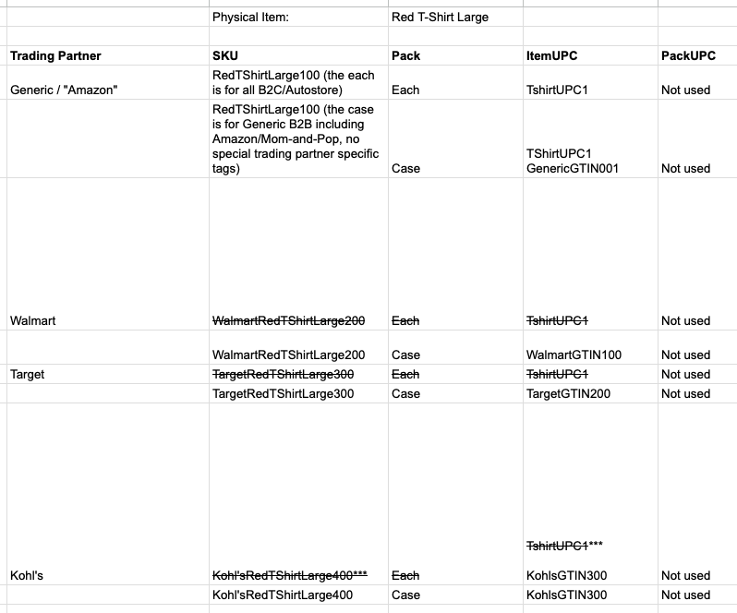

## Components

For product bundles or kits, you must create a separate item for the bundled product as well as items for each component product. The items themselves will be created via FTP pull or direct Data Exchange upload, then an Item Components Data Exchange field mapping will be used to define the parent item <> subcomponents relationship. This data must be set for Kit to Order and Product Conversion with Work Order scenarios described in more detail in the Kitting section of this document. Gerber will use this for Virtual Bundles, such as when a customer orders a baby gift which comes with a blanket, onesie, special box, etc.

## Trading Partners

A trading partner in Deposco represents an external party to the company that is typically associated with an order. The primary types of partners include:

* Customer – Used for partner companies that are purchasing products from the company and are therefore associated with sales orders. Also used for general shipping purposes.
* Supplier – Used for partner companies that a company is buying products from and are therefore associated with purchase orders. Also used for partners that provide drop shipping services.

### Key Assumptions

* Trading Partners are to be configured for the initial implementation. They will be created by GERBER via a Data Exchange CSV upload. Orders will also be imported with a trading partner set on the order header level.

Trading Partners are uploaded via Data Exchange or created manually in the Deposco User Interface. Specific mapping requirements are outlined in more detail in the Data Exchange section of this document.

## Price Lists

You can create price lists to manage different prices for a single item. For example, you may have different prices for sales promotions or for specific trading partners (e.g. Bloomingdale’s, Neiman’s). A price list includes one or more price list detail records. Each price list detail record identifies a specific item, the price for the item, and the start and end date for when the price is effective. If a trading partner has been created for the customer on the order, then you can assign a price list to the customer by using the Price List field on the trading partner record. The price list is then used for pricing on any orders where the trading partner is assigned as the Consignee Partner for the order. If one price list is assigned to the order and a different price list is assigned to the trading partner, then the price list for the order takes priority. If a price list has not been assigned to either the order or the trading partner for the order, then the price in the Unit Price field for single-unit (Each pack) items on the order is used. If a price list has been assigned to the customer by using the Price List field on either the CxCustomer or the TradingPartner entity for the customer, then the price list is used for pricing on any orders for the customer.

Price Lists are uploaded via Data Exchange or created manually in the Deposco User Interface.

## Users

Deposco provides two different features for creating and managing users and passwords: *User Management*, which provides full user management functionality and requires membership in the Admin group, and *Associate User*, which can be configured to provide more limited user management functionality and is available on an application menu.

The Associate User feature is intended for users such as warehouse department managers or assistant store managers, who may need the ability to create and manage users for specific facilities but who should not have full administrative access to Deposco.

### Company Assignments

Company assignments limit users to viewing data and performing tasks for only the companies to which they are assigned. For example, entity lists are automatically filtered to display only entities for companies that the user has permissions for, and picking workflow processes can be configured to require the user to select one of their assigned tenant companies and then display only orders for the selected tenant.

Use the following strategies to set up company assignments for a user account:

* If a user should be assigned to a single tenant company, then select the company in the User of Tenant field on the User Information tab for the user account.
* If a user should be assigned to multiple companies, then enable company assignments in the user management options. Then select the primary company in the User of Tenant field on the User Information tab for the user account, and assign additional companies on the Company Assignments tab.
* If a user should be able to access data for all tenant companies, then leave the User of Tenant field blank on the User Information tab for the user account.

### Key Assumptions

* Users, Groups, and Permissions are set up through the Deposco User Interface to ensure the right users have access to the right functionality/reports.
* Associate Users can be created manually in the User Interface or uploaded via Data Exchange.

## Carton Types

Carton types typically represent the different sizes of shipping boxes, and are used to facilitate the process of entering box dimensions during packing. Carton types are also required for cartonization, which is the process of evaluating the contents of an order to determine the number and size of each shipping carton required for the order. Cartonization is in scope for the initial implementation. With Carton Types uploaded, packing users will be able to select a box size from a drop down menu rather than manually entering in the length, width, and height. Weight will be auto-populated based on pack data and the tare weight of the selected Carton Type; scales will not be used at the parcel packing stations.

### Available Carton Types

* GERBER will upload their available carton types to be used for the initial implementation.
* Carton Types can be defined for use for specific ‘groups’ or order types.

### Key Assumptions

* GERBER will maintain their available carton types and can add as needed.
* Carton Types have accurate dimensions defined.

Carton Types are uploaded via Data Exchange or created manually in the Deposco User Interface. Specific mapping requirements are outlined in more detail in the Data Exchange section of this document.

## Containers

A container is any object that holds items, such as a cart, bin, pallet, or shipping box. A container is also called an LPN (license plate number) since it has a preprinted, sequential barcode label for tracking.

### Types

* **Cart** - typically used for picking carts or for carts that are used for moving inventory. Carts are reusable containers.
* **Pallet** - typically used for inventory containers. Inventory may be received, put away, and moved while on a pallet container.
* **Transient** - typically used for reusable containers such as totes or bins.
* **Shipping** - typically created automatically by the system for containers that are shipped, including both parcel shipping containers and pallets that are used for shipping. Shipping pallets are typically identified with a secondary container type of Pallet.

### Key Assumptions

* A container is associated with a single location at a time.
* Multiple stock units can be assigned to a single container.
* Containers can be assigned to another container (e.g. shipping boxes or LPNs on a pallet).
* During receiving, a container can be associated with multiple receipt lines.
* During shipping, the container is associated with a shipment before the shipment completes. After the shipment completes, the container becomes a container history (ContainerHist) entity, which is a separate entity from a container.
* All totes, bins, and carts are uploaded to the system. This allows the system to perform validations on user scans during handheld processes.
* All totes, bins, and carts are barcoded and can be scanned using an RF device.

Containers are uploaded via Data Exchange, created manually in the Deposco User Interface, or can be created automatically in certain processes such as when receiving an ASN or picking to a pallet. Specific mapping requirements are outlined in more detail in the Data Exchange section of this document.

## 

## Printing in Deposco

Printing in Deposco will be set up by GERBER in regards to the following entities:

### 

### Printer Detail

* Printer Details are used to tie the printer name in Deposco to the GERBER Deposco Print Client.
  + GERBER will run “Printer Validations” in Deposco during setup to ensure that each printer is properly configured.

### Printer Assignment

* Printer assignments tie specific reports to specific Printer Detail.

### Resource

* A Resource houses a collection of printer assignments.
* A user's assigned Resource will determine which printers they can use to print specific documents.
  + Users can only be assigned to one resource at a time.
* A handheld button is available to users to easily switch their assigned Resource.
  + Additionally, this can be set for users though the Deposco UI.

# Facility

The Deposco software is for use in the following facility:

**Summerville, South Carolina Facility:**

Facility Number: US7F

Address:

200 Trade Blvd

Summerville, SC 29483

US

# Integrations

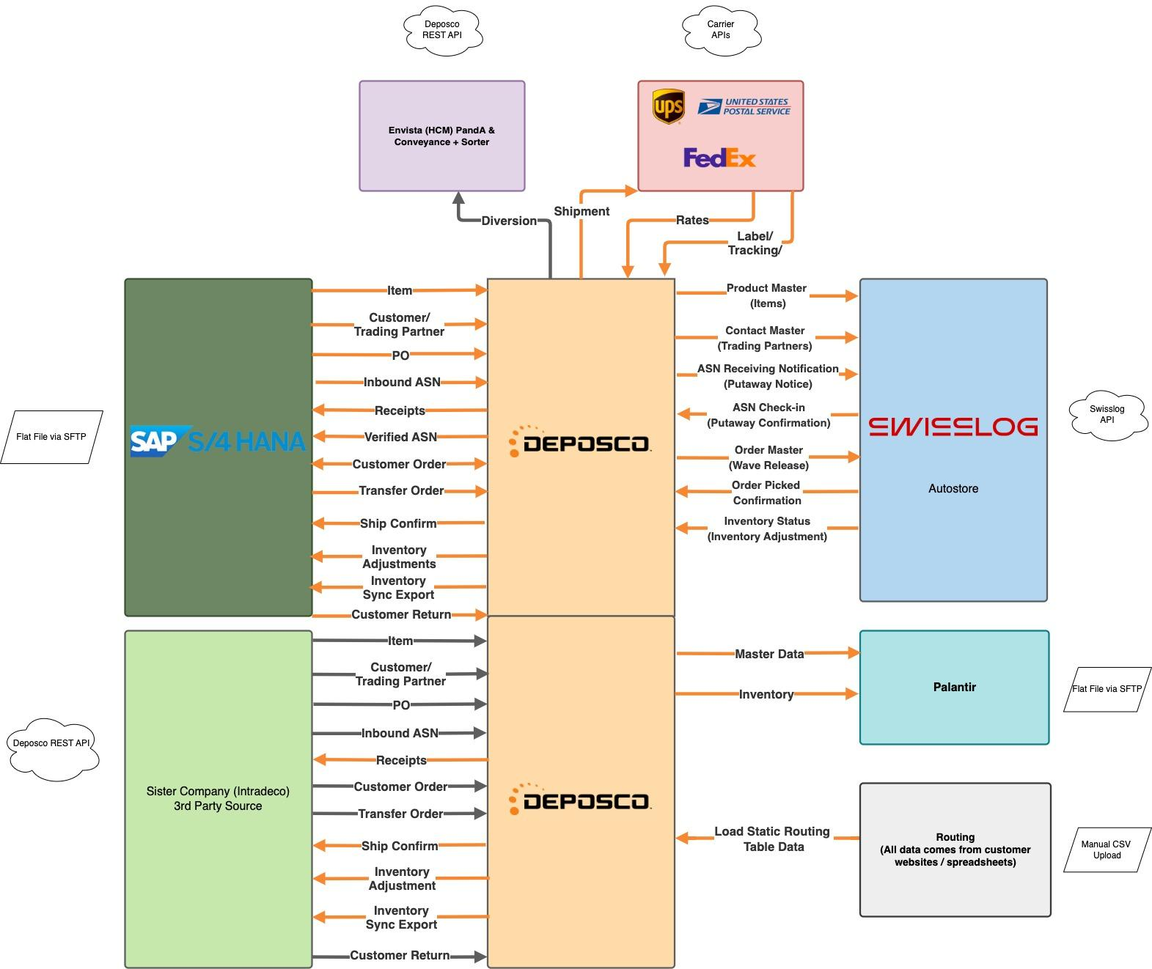

## SAP S/4 Hana

Gerber Childrenswear uses SAP S/4 Hana as their ERP. Deposco will import the following data from SAP:

* Items
* Trading Partners
* Purchase Orders
* Inbound ASNs
* Customer Orders
* Transfer Orders
* Customer Returns
* ~~Work Orders~~ [work orders will not be used]

Deposco will export back to SAP the following:

* Purchase Order Receipts
* Verified ASN Confirmation
* Customer Return Receipts
* Customer Orders
* Ship Notifications
* Inventory Adjustments (+/- adjustments which happen throughout the day)
* Inventory Sync Export (periodic export including Total On Hand Qty, Total Reserve Qty, Total Pickable Quantity)
* ~~Work Order Build Results~~ [work orders will not be used]

Deposco will accomplish this by building field mapping templates with the required fields, establishing connectors with an FTP or SFTP site with defined file paths, and running automated schedulers which either pull or push flat file data to the file hosting site. Gerber can then pull the CSV data from those folders to upload into SAP. Gerber will have the ability to modify incoming or outgoing field mappings as needed.

Shipment line information is created within Deposco as soon as a shipment is hard closed. Receipt line information is created within Deposco as soon as a receiving user scans in product in the Deposco application. Work orders will not be used and have been removed from the original integration diagram. Shipments, receipts, and verified ASN confirmation data will be sent to SAP on a scheduled basis. Gerber will have the ability to modify the scheduled frequency of these exports as needed.

SAP integration flows will be used for both the Summerville facility and the China facility.

Inventory adjustments including increases or decreases in inventory made via the Adjust Inventory or Cycle Count processes. In addition, the following movements will need to trigger adjustments in SAP.

* Movement from available location to unavailable location (e.g. to Damaged Goods)
* Movement from unavailable to available location
* Change of a location from available and ready to “On Hold” in Deposco
* Change of a location from “On Hold” in Deposco to available and ready

**Note**: Deposco’s current inventory ledger does not create records when a location is changed from Available to Unavailable (“On Hold”). This was a gap identified in the Gap Matrix at the end of this design document. There is ongoing development for a new enhanced Inventory Ledger which will create records for items which exist in a location whose status changes from available to unavailable or vice versa. This new Inventory Ledger is slated for production release in April 2025. As part of the initial implementation, Deposco and Gerber intend to implement this new base product offering for the capture and communication of these ‘available’ vs ‘unavailable’ activities to Gerber’s SAP.

In addition to the transactional inventory adjustments which are communicated to SAP throughout the day, Deposco will configure a scheduled Inventory Sync export file which include Total On Hand Qty, Total Reserve Qty, and Total Pickable Quantity. The Gerber team will be able to add additional inventory measures to this report.

## Intradeco

Intradeco, Gerber’s parent company, will also need data to flow to and from Deposco. Intradeco will integrate with Deposco’s REST API to post the following data to Deposco:

* Items
* Trading Partners
* Purchase Orders
* Inbound ASNs
* Customer Orders
* Transfer Orders
* Customer Returns
* ~~Work Orders~~ [work orders will not be used]

The original integration scoping diagram and SOW indicate that Deposco will trigger the following data exports via FTP / SFTP to Intradeco.

* Purchase Order Receipts
* Customer Return Receipts
* Ship Notifications
* Inventory Adjustments (+/- adjustments which happen throughout the day)
* Inventory Sync Export (periodic export including Total On Hand Qty, Total Reserve Qty, Total Pickable Quantity)

However, after further discussion, Gerber’s middleware provide ‘Ecom Services’ will instead both post and pull data from the Deposco REST API for Intradeco including receipt, shipment, and inventory data.

The transactional inventory adjustments which are created throughout the day will be pulled by Intradeco (via Ecom Services) using the Deposco REST API ‘InvAdjustment’ endpoint. In addition, the Enterprise Inventory API endpoint will be used to pull a periodic snapshot of inventory measures including Total On Hand Qty, Total Reserve Qty, and Total Pickable Quantity.

## Shopify, Channel Advisor, and NuOrder

Gerber Childrenswear uses site e-commerce platforms: Shopify, ChannelAdvisor, and NuOrder. Deposco does have direct socket integrations with these platforms with the following existing touchpoints:

* Item/Channel Listing Pull
* Customer Order Pull
* Ship Notice Push

Direct integrations with these platforms is mentioned in the initial scoping documentation. However, Deposco recommends an alternative approach. All customer orders need to live in SAP. Orders must be allocated (or “committed”) in SAP which creates a delivery which serves as the fulfillment order from Deposco’s perspective of what is to be picked and shipped. If Deposco were to pull orders directly from e-commerce platforms and push the order to SAP, then Deposco would already have an existing order before SAP has ever created the delivery (or “pick ticket”) which is actually available to fulfill. Similarly adjustments and ship notifications would need to be sent to multiple systems and potentially cause discrepancies. Deposco typically communicates directly with the ERP and allows the ERP to push and pull data from e-commerce platforms. In this case, orders would flow from the ecommerce platforms to SAP and then pull from SAP into Deposco. Deposco would send ship notifications back to SAP. Gerber would manage the flow of inventory from SAP to the e-commerce platforms.

## Autostore

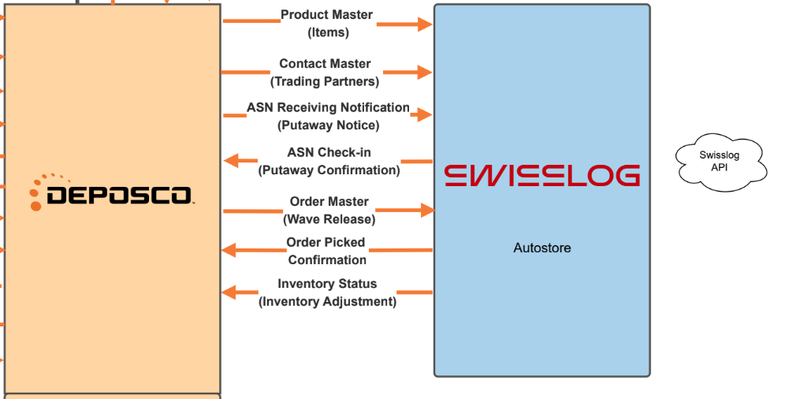

The Deposco integration with AutoStore automated storage and retrieval systems (ASRS) enables you to use AutoStore robots for picking, cycle counts, and replenishment. Deposco will build an integration to Autostore for Gerber Childrenswear by leveraging the API provided by Swisslog, an AutoStore partner, to send and receive data between Deposco and AutoStore for items, trading partners, putaway induction, pick waves, pick confirmations, and inventory adjustments. Cycle counts will be done directly in Swisslog and communicated to Deposco as adjustments.

Data is passed between the two systems through socket interfaces. In most cases, data is sent to AutoStore when certain events occur. For example, order, item, and picking location data is sent when a pick wave is released.

### Item Integration

The Export Item interface sends items from Deposco to AutoStore on a scheduled basis to ensure that data is synchronized between the two systems. (This is the only scheduled interface for the AutoStore socket integration; all other interfaces are event-based.),

Only items that were created or updated since the last time that the scheduler ran are sent. In addition, the integration supports only Each packs (pack quantity of 1). After an item is successfully sent to AutoStore, a channel listing is created to link the item in Deposco with the item in AutoStore. Gerber Childrenswear will not require advanced item attribute tracking with Autostore including lot numbers, serial numbers, and expiration dates.

### Pick Wave Integration

When pick waves are built, orders are evaluated and grouped into the pick waves based on criteria in the build pick wave profile, and pick tasks are created. When a wave is released, Deposco will hard allocate available inventory to specific orders and create pick tasks. All orders which Deposco waves to Autostore will create pick tasks for the one Autostore black box location.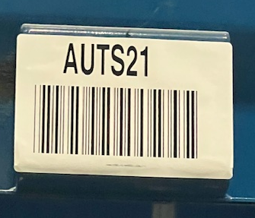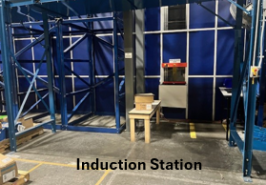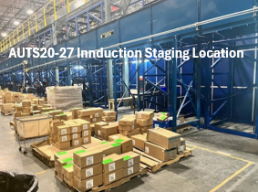

Deposco will send pick tasks for several different types of orders to Autostore.

Order Types:

1. Business to Consumer (B2C) - Regular Single Unit orders
2. Business to Consumer (B2C) - Regular Multi Unit orders
3. Business to Consumer (B2C) - Retail orders including Amazon and Kohls
4. Special Embroidery Orders
5. Virtual Bundle Orders

Immediately following wave release, within Deposco pick tasks will be stored in a state of ‘Inactive’ on pick waves in a status of ‘Released’. Following wave release, Deposco will notify Swisslog of the orders, SKUs, and allocated quantities which were released using this Order Master touchpoint.

Swisslog will maintain the queue of waves Deposco has communicated and the Gerber team will be able to manually control when to release the waves queued in Swisslog for picking. This will be managed on the Swisslog side. From Deposco’s perspective, once tasks are sent they will remain in a pending (‘inactive’) status until either Swisslog sends us a pick confirmation or one of the rollback methods described below is used.

Deposco will not send any wave cancellation or ‘undo wave release’ messages to Swisslog. Instead, the Gerber team will use one of two methods if an order is allocated to Autostore, but should not be fulfilled:

**Method 1: Undo wave release in both systems**

The Gerber team will be able to manually rollback the release of allocation directly both in Swisslog and in Deposco. In Deposco, the ‘Undo Wave’ process can be used to rollback an entire wave or ‘Undo Wave - Order’ can be used to roll back the allocation of a specific order (or set of orders) on a wave.

**Method 2: Pick whatever has been allocated to Autostore, adjust after picking**

The Gerber team will also be able to move forward with picking all tasks which have been allocated and communicated to Swisslog. This picking will be sent back to Deposco and Deposco will mark the order as picked. A supervisor will be able to manually check a flag on the order header in Deposco to flag it as ‘do not ship’. Deposco will use business rule logic in the Cubed Packing process to throw an error message at the pack station to prevent a user from shipping a flagged order. The user will set the order aside. A supervisor will be able to then use the Deposco ‘Rollback Order After Picking’ process to undo completed the pick tasks and un-allocate the order. The product can then be inducted back into Autostore.

### Replenishment Integration

Deposco will use Directed Replenishment logic (using Storage records which define min/max thresholds per SKU which can be stored in Autostore) to direct operators to pull pallets from Reserve locations and stage to the single Autostore Replen staging location. An operator will then use the Move Container process to move each pallet from the Autostore Replen location to one of the available Autostore port locations. This move of the container will trigger a containerStaged event in Deposco and a message to Swisslog will be sent.

An operator will then handle induction directly in the Autostore. Once the stock is put away into Autostore, Deposco will receive a stock movement confirmation known as “ASN Check-in Confirmation”. Deposco will then systemically move the stock from the Deposco Container in the port staging location to the Autostore blackbox location.

Once all stock has been putaway, the staged container will be empty systemically in Deposco. Within the Autostore black box location, Deposco will merge stock such that there is a maximum of one stock unit record per SKU stored in the Autostore location.

For example, say Autostore has a stock unit record for 100 units of Item123. From a Reserve location outside of Autostore, an operator in Deposco pulls 50 units of Item123 on a pallet numbered LPN123, stages, and then that pallet is moved to a port location. Deposco will notify Swisslog via the ASN Receiving Notification message, a user will induct the 50 units of Item123 into Autostore, and Deposco will then receive an ASN Check-In Confirmation message from Swisslog. Deposco will merge the 50 units inducted with the existing 100 units stored and maintain a single stock unit record of 150 units in the Autostore black box location. The pallet numbered LPN123 will be empty in the port staging location and available for re-use in replenishment.

Alternatively, a container (such as a pallet) may be moved directly to a port location using the Move Container process. This will also raise the containerStaged event, notify Autostore, Autostore will perform the induction, then Autostore will notify Deposco, and Deposco will decrement inventory from the port location and increment inventory in the Autostore location.

### Parent To B2C Conversion Process

Prior to Deposco, Gerber maintained separate SKUs for ‘eaches’ and ‘cases’. Product was stored outside of Autostore in the Case SKU and needed to be converted to the Each SKU prior to induction into Autostore. For example, the Case version of a SKU may be SKU 12345 which has an inner pack of 12 and the Each version of a SKU is SKU B2C123456 has an inner pack of 1. In Deposco, there will be a single SKU with multiple related Pack Types. For example, SKU 56789 has 2 packs: 56789–Each–1 and 56789–Case–12.

Storage records will maintain minimum and maximum quantities in terms of Eaches for the Autostore Replen location. Initially, product would be received into the warehouse and putaway to a reserve rack location in cases. During replenishment to Autostore, there would be no need to manually convert from one SKU to another. Instead, the operator would be directed to pick the Cases from the reserve rack location and move that to the single Autostore Replen location adjacent to the Autostore. Upon staging, Deposco will automatically downconvert the cases to Eaches. So if the operator picked 4 Cases from the reserve rack location, upon staging their pallet of Cases to the floor Autostore Replen location Deposco would then store 48 Eaches. An operator would then use the Move Container to move the pallet from the general Autostore Replen location to a specific Autostore Port location. Upon the move of a container (also referred to as a ‘cart’ or ‘pallet’) to a port location, Deposco would then notify Swisslog that 48 Eaches are ready to be inducted. Swisslog would then induct and then send Deposco a putaway confirmation back to confirm the number of Eaches which were successfully inducted.

### Cycle Count Integration

Gerber will handle Autostore cycle counts within Autostore itself and send the total quantity to Deposco as an inventory adjustment. Deposco will create variances if any exist between the Autostore count and Deposco’s inventory in the Autostore location. These variances can require manager approval or be auto-approved. Deposco will not send cycle count tasks to Autostore.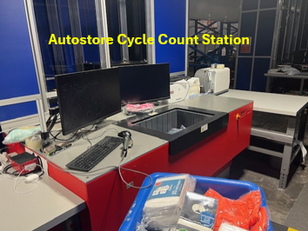

### Inventory Adjustment Integration

Inventory adjustments are changes to inventory that are initiated by the Autostore system and communicated to Deposco. This is initiated by Autostore and is not sent as a response to either an incomplete Pick Confirmation or a Cycle Count Confirmation. An Inventory Adjustment is a way for the Autostore or Swisslog to confirm an out-of-band change in the inventory in the Autostore.

Scenarios that will trigger an operator to make an Inventory Adjustment from Swisslog:

1. Manual Adjustment/Correction by an operator in Swisslog
2. Pick Exception - a shortage during picking will not trigger any Deposco exceptions management logic. Instead, an adjustment will be initiated by Swisslog and communicated to Deposco via this Inventory Status touchpoint
3. Cycle Count - cycle counts will be managed directly in Swisslog and any inventory changes from those counts will be sent as Inventory Status Adjustment messages

When an inventory correction is received from Swisslog, Deposco will need to increment or decrement the Autostore black box location. The message from Swisslog will contain bin-level previous quantity (prevQuantityOnHand) and new on hand quantity (quantityOnHand). Deposco will calculate quantityOnHand - prevQuantityOnHand and then add the sum of that calculation to the existing stock unit quantity. For example, in a message where quantityOnHand is 18 and prevQuantityOnHand is 14, Deposco will add +4 to the existing stock unit record of 100 total in Autostore to now store a single stock unit record of 104 units.

The associated stock unit for the item in Deposco is created, updated, or deleted, as applicable. In addition, an Inventory General Ledger (“IGL”) record is created for each change.

**Envista Print and Apply & Conveyance Sorter**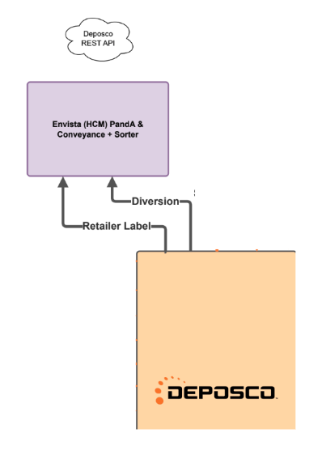

For the Deposco implementation, Envista will no longer be used for B2B carton labeling, but will be used for B2C parcel diversion.

1. Sorter for E-commerce orders picked in Autostore. In this use case, e-commerce orders picked in Autostore would be packed in Deposco, Deposco would print off the shipping label, the packer would apply the label to the outside of the package, and set the package on the conveyor. Then Deposco will send Envista the tracking number and carrier information. Envista will scan the shipping label on the package and divert to different gaylords based on whether it needs to go to the UPS, FedEx, or pallet staging areas.
   1. Deposco to send Envista tracking and carrier information for e-commerce orders to be used by sorter
   2. Amazon orders will be diverted to their own area.
2. Previously Deposco had scoped use of the Print-and-Apply machine for B2B carton labeling for retailer compliant SSCC labels. The Gerber team decided in March 2025 to discontinue use of the Envista PANDA machine in its operations. Deposco will no longer develop an integration to the Envista PANDA machine and the zone which the machine previously occupied will be replaced with racking which will serve as extension of the existing Full Cases zone. The Full Cases zone is used for picking ready-to-ship full cases for B2B orders. Gerber users will handle the application of SSCC carton labels.

## Routing Imports

Gerber manages freight routing for Retail B2B customers outside of Deposco. A flat file will be used to upload and store key routing attributes on the order header of Sales Orders including the SCAC, PRO number, and Load ID. Deposco will then use business rules to stamp these values onto the Trip record when a carton is scanned onto a trip. Alternatively, trips may be created via a Process Action Link on the order header and freight data keyed in manually on the trip record prior to fulfillment processing. This is described further in the Trip Management section of this document.

**Note**: Routing is an open topic included in the Gap Analysis matrix at the end of this design document. Deposco and Gerber acknowledge that initial expectations on how routing was to be handled were misaligned. Deposco expected routing logic to be handled outside of Deposco with trip data then uploaded/keyed into Deposco. The Gerber team expected incoming orders to be evaluated for estimated cartons, weight, volume, route to destination, etc and then conditional if-then routing logic to live in Deposco and determine carrier service, label type, and consolidator information similar to their current system. The Gerber team has provided Deposco an overview of routing requirements and documents stored in the shared [Routing Folder](https://drive.google.com/drive/folders/15QMHkl5Z4RzXrfkLGLEwwNvmGNGf0LwE?usp=drive_link). Deposco is evaluating internally with product, engineering, and professionals services teams on how these requirements might be handled within Deposco.

## Palantir

Gerber uses Palantir as a primary platform for Business Intelligence. Data from Deposco can be pulled via API, SFTP exports with field mappings defined by Deposco and/or Gerber team, or from a specialized Snowflake instance with a subscription to Deposco’s Data Archive product. Data Archive is updated once every 24 hours at 4AM CST. For use cases requiring more immediate data, API or SFTP can be used.

## 3PLs

Gerber has a relationship with a 3PL in China. The 3PL in China has interest in generating carton labels from Deposco and using auto-pick/auto-ship processes for fulfilling orders. For orders fulfilled out of the 3PL in China, Deposco would pull orders from SAP and send ship confirmations back to SAP.

Deposco would pull Purchase Orders coming to the Gerber DC from the 3PL from SAP. Inbound ASNs would also be pulled from SAP. Users at the Gerber DC would receive in Deposco and Deposco would send receipt confirmations back to SAP.

1. A Purchase Order is generated in SAP and pulled into Deposco. A user receives in product into the China facility against that PO. Product is received into 1 location within that facility and that location is considered Pickable. Deposco will send a receipt notification back to SAP.
2. A Sales Order is generated in SAP. SAP allocates to the China facility and creates a Delivery. Deposco pulls that Delivery in and creates a corresponding fulfillment order in our system.
3. A user goes to the order header of the fulfillment order and clicks a process action link called 'Auto Pick'. This will automatically wave and pick the order onto a single system generated pallet container.
4. A user will then enter the Deposco process called 'Print2Panda'. They will scan the single system generated pallet container. Deposco will then automatically generate and print SSCC carton labels.
5. A user will then enter the Deposco process called 'Assign Trip to Container' where they will scan the master pallet and it will be loaded onto an outbound trip. They will then use the Close Trip button to systemically ship out the pallet and all of the associated cartons.
6. Deposco will then send a ship notification to SAP which will then handle the corresponding EDI ship notification to Burlington.

In summary, this is a simplified version of the typical Deposco workflow that allows users to print SSCC labels by scanning an 'auto picked pallet' which represents the entire order. Data flows in and out of SAP such as PO pull, SO Pull, receipt notification, and ship notification will be handled by the Deposco integration.

**The original Statement of Work scoping documentation only included 1 facility - the Summerville Distribution Center. Following design, a second Statement of Work was proposed and signed by the Gerber team to add the China Facility as a 2nd facility to the scope.**

## UPS

Gerber Childrenswear will use the base Deposco UPS integration to request shipping label information.

Gerber Childrenswear Requirements:

* Gerber Childrenswear will have up to 10 UPS accounts listed in Deposco, for their US7F facility in Summerville, South Carolina.

## FedEx

Gerber Childrenswear will use the base FedEx integration to request shipping label information.

Gerber Childrenswear Requirements:

* Gerber Childrenswear will have up to 10 FedEx accounts listed in Deposco, for their US7F facility in Summerville, South Carolina.

## USPS (Stamps)

Gerber Childrenswear will use the base Stamps integration to request shipping label information.

Gerber Childrenswear Requirements:

* Gerber Childrenswear will have up to 10 Stamps accounts listed in Deposco, for their US7F facility in Summerville, South Carolina.

# Inbound Processes

This section outlines all inbound related processes. This includes Receiving, Returns Processing, Staging received items, Putaway, Purchase Order management, and Inbound Transfer Order management.

## Inbound Order Management

This section outlines how inbound orders (inventory coming into the warehouse) are defined, managed, and monitored in Deposco.

### TypesofInboundOrders

The three types of Inbound Orders are Purchase Orders, Inbound Transfer Orders, and Customer Returns. These orders can be viewed by certain data points within the Deposco User Interface (UI) on the OrderHeader and OrderLine Entity.

#### Purchase Orders

Inventory is listed on a Purchase Orders (PO) with items, pack types, and quantities listed as separate lines. As inventory is received against these lines, unique receipts are tied to the PO line, and the net received quantity is updated.

All types of Purchase Orders will be stored on the OrderHeader entity with a Type of “Purchase Order”. Purchase Orders and Purchase Order Lines can be updated/canceled in the Deposco User Inter face (UI) on the OrderHeader and OrderLine Entity; no integration updates or inventory change translations to another system are included within this capability. Purchase orders will have the item quantities in either Eaches, the lowest base unit of measure for the item, or Cases.

### GERBER Purchase Orders

Purchase Orders can be created within Deposco via multiple methods including:

1. Created in SAP and pulled into Deposco via an automated SFTP import scheduler.
2. Created in Intradeco’s ERP and posted directly to the Deposco REST API.
3. POs can be imported to Deposco via CSV upload in the Data Exchange application. Gerber does not plan to use this functionality.
4. POs can be created directly within Deposco via the PO Entry application where a user enters supplier, items, and other order information to create a PO in the UI. Gerber does not plan to use this functionality.
5. Blind receiving - where a PO can be created on the fly without a pre-existing PO in the system to receive against. Gerber will not be using this functionality. All receiving will be performed against an existing order in Deposco.

#### Inbound Shipments

An inbound shipment is a shipment that is created outside of Deposco when a supplier sends Gerber stock to fulfill a purchase order. An inbound shipment is also referred to as an advance ship notice, advance shipping notice, or ASN.

Inbound shipments can include stock for a single purchase order or for multiple purchase orders. Similarly, a purchase order can be fulfilled with a single inbound shipment or through multiple inbound shipments.

Gerber will create inbound shipments through FTP/SFTP pulls from SAP and from direct API integration managed by Intradeco.

#### Inbound Transfer Orders

Deposco manages the transfer of inventory between facilities using two types of orders: *inbound transfer orders* and *outbound transfer orders*. For facility transfers controlled by the Deposco system, when an outbound transfer order is shipped from the source facility, an inbound transfer order is automatically generated for the destination facility. An inbound transfer order can also be created in external systems and sent to the Deposco system through FTP/SFTP or API. Receipt of inventory that was listed on an Inbound Transfer Order is then managed through the Receiving process.

Gerber Childrenswear will not use transfer order functionality, but instead create transfer orders as Purchase Orders in the Deposco system.

#### Customer Returns

A Customer Return is inventory that was sold on a Sales Order, and is being sent back to the warehouse by a customer. Customer Returns can be created via integration (i.e. SFTP pull from SAP) or directly within Deposco. They can then be received using the same Receiving process as Purchase Orders, but with specific configuration for Customer Returns receiving such as receiving to a default location of Returns. GERBER can create returns in one of four ways:

1. SAP Integration - Deposco does support creating Customer Returns by running a scheduled pull request to SAP via SFTP. This will be the primary source of Customer Returns.
2. Deposco API - Intradeco will post Customer Returns directly to the Deposco API.
3. Create RMA - Within Deposco, a user scans incoming the tracking number or enters the original Sales Order number in the Create RMA process. This generates the Customer Return with a link to the original sales order in Deposco for the line items which were originally shipped out of Deposco. The user can then immediately receive against that newly created RMA or another receiver can receive against it. Gerber does not plan to use this functionality.
4. Blind RMA - User enters an ad hoc number and immediately receives stock. This creates and receives a Customer Return simultaneously. There is no link to a specific Sales Order. Gerber does not plan to use this functionality

GERBER has stated that all customer returns will come from SAP. **\*\*Deposco to confirm if Intradeco will post Customer Returns via API.**

During returns received, a user will scan in items and be able to enter a reason code for the return. This reason code can be generic (e.g. “Return”) or specific (“arrived damaged”, “arrived too late”, “did not receive what was ordered”, and so on). Any quality control process can be performed within this Returns location and then product can be restocked via a move to an available inventory location or instead moved to another location to be decremented such as “Damaged Goods”.

## Receiving Processes

Receiving processes are used to perform the receipts of the Inbound Orders outlined above and create inventory in Deposco. The receiving process can be used real time as a part of the trailer unload or may be received after all inventory is physically unloaded, as is common with live unloads where carrier charges may apply if a certain duration is exceeded. More scanning in the receiving process requires more time to complete the process, but has the benefit of improving accuracy. The generic Receiving location that product is received into will be set up as a non-pickable location. Gerber Childrenswear will move received items to a pickable location with the configured Move processes.

#### Purchase Order Receiving

GERBER will have one primary handheld button to receive Purchase Orders known as Receiving. This process allows a user to receive stock against an existing Purchase Order or Customer Return. Two instances of Receiving will be used: ASN Receiving and Returns Receiving.

Purchase Orders will be received to a Receiving location. Gerber will receive all products as either eaches or cases. Pallets will generally be physically inspected and sorted into single SKU pallets before receiving. After receiving, Gerber will use a separate step for system-directed putaway to move the pallet to a putaway location.

Purchase Orders can be subject to a QC Process after receiving.

#### ASN Creation

* ASNs will be treated as Inbound Shipments in Deposco which are linked to parent Purchase Orders.
* Inbound Shipment records will be created through SFTP pulls from SAP and will be posted directly to the Deposco Rest API by Intradeco
* Deposco supports setting the Inbound LPN on Inbound Shipment lines which contain the quantity of each item in each incoming carton. This allows a receiving user to only scan in LPNs without scanning product or validating quantity. For Gerber, within the ASN record, LPN numbers (carton numbers) will NOT be provided from the API/FTP. Gerber does intend in the future to add this functionality in post go live once line level pallet ID data is available on the ASN lines.

#### ASN Receiving

* ASN arrives at the distribution center.
* ASN lines’ order pack quantity can come into Deposco as either Eaches or Cases. Gerber’s ASN lines will primarily be in units of Eaches, but may be received at the case level.
* Under Inbound’s handheld group, an **ASN Receiving** function will be provided to handle inbound ASNs. The process breakdown is as follows:
  + The user will scan or enter the ASN number into the identifier screen.
    - Barcodes containing the ASN number will be provided on document printouts.
  + If the user scans a purchase order number and there is an inbound shipment for the order, you are automatically directed to begin receiving stock for the shipment. If there are multiple inbound shipments for the order, the Shipment Selection screen appears. Select the inbound shipment to receive against, and then select Submit.
  + After scanning the ASN number, the Receive Item Screen appears with a list of items on the order or shipment.

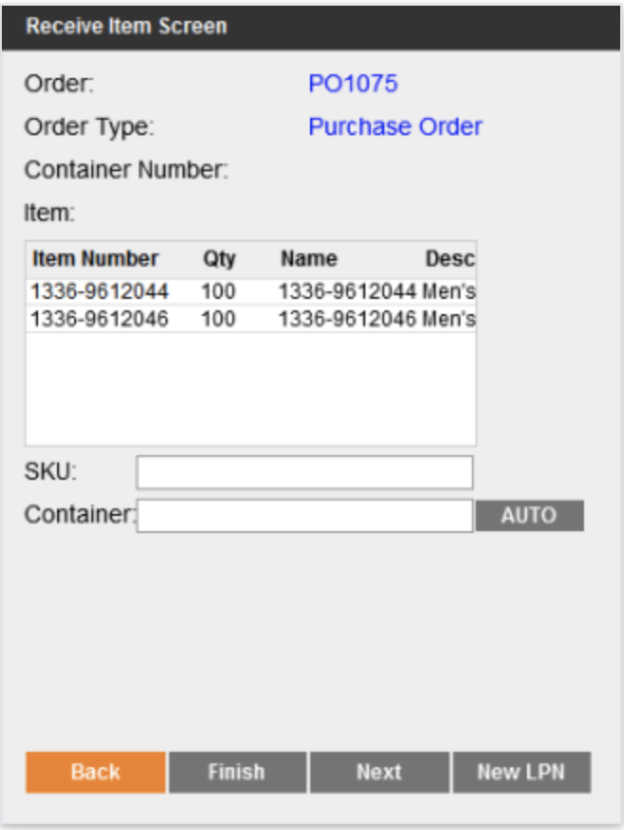

* + The user will scan an item UPC and the master pallet number to receive onto.
  + Gerber can scan generic pallet labels to create the pallet on the fly, or use the ‘Auto’ button to have Deposco generate a new pallet number, or can import master pallets into the system using the Container Data Exchange import. The pallets should be imported with a container type of “Cart” into the system.
  + Gerber will print out master pallet labels with barcodes and have them placed on these master pallets.
  + Stock that you receive is assigned to the container and the default receiving location. As you continue to receive stock for the order or shipment, the stock is automatically assigned to the same container.
  + If the container is full and you need to start using another container, select New LPN on the Receive Item Screen. The Identifier Input screen appears. Scan another container to begin receiving to, or select AUTO to create a container. Then select Submit and continue receiving stock for the shipment.
  + If the Image button appears on the screen, then optionally select the button to view the image for the item on the View Item Image Screen. When you finish, select Back to return to the Pack Quantity Screen.
  + Select the pack type from the list.
  + In the Receive Qty field, enter the quantity of stock to receive for the item.

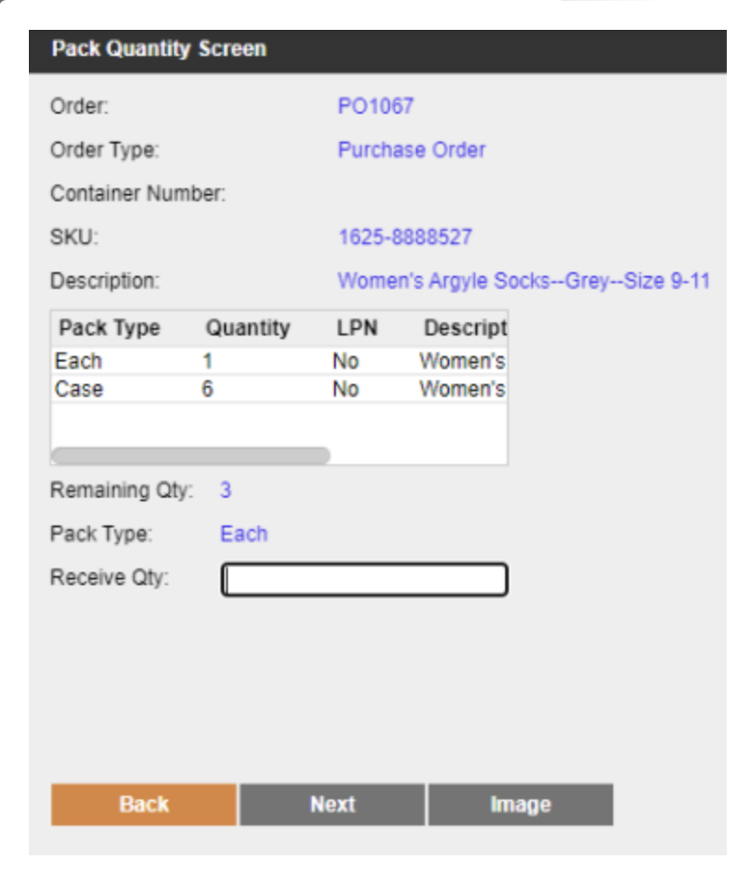

* + Select Next. You are returned to the Receive Item Screen, and the item you just received no longer appears in the Item list.
  + To receive more stock for the order or inbound shipment, scan or enter another item and then repeat the previous steps.
  + When you are finished receiving stock for the order or shipment, you are returned to the Identifier Input screen, where a confirmation message appears.
  + To receive stock for another order/shipment, scan an item from the order, the order number, or the shipment number. Or, if you are finished with receiving, select Back to return to the Main Menu for the handheld menu.
  + ASNs will be ordered in the Each pack type; they may be received as Eaches or as Cases.
  + If received as cases onto a pallet and moved to either a Reserve Storage or Full Case Picking location, Deposco will preserve the Case pack. Otherwise, if moved to a Split Case Picking location, Deposco will automatically downconvert Case packs into Eaches.
  + Deposco will set up a Verified flag on the Inbound Shipment record. This flag will be manually toggled by a supervisor after full or partial receipt of an ASN. This flag will be included in the Verified ASN push back to SAP to indicate to SAP that the receipt has been confirmed and SAP can close the ASN to finish its processing.

###### Handheld Process Configuration

1. The order types allowed to be received in this process are ‘Purchase Orders’.
2. GERBER’s ASN Receiving process will allow for over-receiving. The over-receiving tolerance will be set globally for all items and be configurable by Gerber. For example, an over-receiving tolerance of 1.2 means 120% of the order line quantity is the maximum amount which can be received for that order. So for an order line of 100 units, a maximum of 120 may be received.
   1. If needed, the GERBER team can configure item specific over-receiving tolerances on the Item Entity.
   2. GERBER will have the option of changing the over-receiving tolerance or to disable it within the scope of this project
   3. If more product is physically received than what was ordered, a receiving user will be able to receive up to the maximum threshold. If more product is physically received than is allowed by the maximum threshold, then a new order will be created and received.
3. GERBER’s ASN Receiving process will not allow for receipt of items not on the Purchase Order. If items arrive not on the expected PO, either a new PO can be created or the existing PO will be modified. A PO cannot be modified after receiving has already begun for a PO.
4. Inventory received through this process will be placed in the Receiving location for POs or the Returns location for Customer Returns.
5. Users will have the ability to print Item labels for the quantity of the item received directly within the receiving process. Ad hoc printing of labels outside of the receiving process will also be an option.
6. For ASN Receiving, the user will enter the number of eaches or cases being received. Deposco does optionally support grocery scan receiving to receive product only via scans rather than quantity entry.
7. All items in the system will have at minimum an Each pack type. Higher level pack types (cases or pallets) can be received if the appropriate master data exists.
8. PO order lines may be in Eaches or Cases. If in cases, a user will be able to receive at either the case or each level. When putting away to a reserve location, this pack type will be maintained. So if received in Cases and putaway to reserve location, the stock would remain in units of Cases.
   1. Once that stock is brought down into a pick location of type ‘Split Case Picking’ then the case will automatically be broken down into units of Eaches. For example, an item could be received as 1 Case of 30 Eaches, putaway as 1 Case, brought down into a picking location as 1 Case and then automatically broken into 30 Eaches. A user would then be able to pick and ship at the Each level.
   2. If instead stock is brought down from Reserve to a pick location of type ‘Full Case Picking’, then the Case pack type will be preserved and no pack conversion will take place.
9. If line level Inbound LPNs were set, the receiving user would enter a PO to receive against and be able to receive by scanning the LPN barcode on the incoming product. This requires the Inbound LPN field to be set at the line level. This can be used with multiple SKUs per LPN.
   1. For example, say PO123 has one line for 10 eaches of Item1 with an Inbound LPN set to LPN001 and a second line for 20 eaches of Item2 with an Inbound LPN also set to LPN001. A receiving user can enter the handheld receiving process for PO123 and scan LPN001 and a container with the corresponding number will be created in Deposco containing one stock unit of quantity 10 eaches of Item1 and a second stock unit of quantity 20 eaches of Item2. The LPN can then be moved or added to a pallet and the associated stock units will be moved along with it.
   2. This process can also be configured to support receiving LPNs across multiple POs.
   3. Gerber has stated that they will not have this carton or pallet level information on the ASN so this functionality will not be used.
10. Packs which are missing dimensions will have a New Pack Flag enabled. When they are received for the first time, the product dimension data will be captured in receiving. Alternatively, this data will be uploaded via a Pack record import in Data Exchange.
11. No Lots, Serials, Expiration Date, Born on Date, or any other attribute will be captured and is considered out of scope.

[All item tracking functionality (including lot numbers, serial numbers, expiration dates, and born on dates) is out of scope of the current SOW. If this functionality is needed in the future, this would require an additional statement of work]

#### Customer Return Receiving

GERBER will have a separate handheld button to receive Customer Return Orders. RMAs will be created within Deposco via either SFTP pull from SAP or from direct API integration by Intradeco.

**Returns Receiving**

1. The user enters the Returns Receiving process and enters the Customer Return or RMA number.
2. The user goes through receiving steps of scanning and confirming the item and quantity to receive.
3. Stock will be incremented in the Returns location. GERBER can add reason code capture if required. At this time this is not necessary. The reason code would be tracked in the Inventory General Ledger. Reporting can be built to track this.
4. The return would be tied to a specific sales order.
5. Returns location will not be pickable and inventory in that location will not be considered available to promise
6. After stock is incremented into Returns, it will be moved to either:
   1. an available inventory location such as a reserve location or pickable location
   2. a staging location such as Damaged Goods, Needs Box, Destroy, etc. From there, a separate inventory adjustment would decrement the on hand units. These adjustments would be tracked in the Inventory General Ledger. Alternatively, the units can be moved to another inventory location.

Deposco native methods of creating RMAs using either Create RMA or Blind RMA functionality will not be used but are described below for reference.

**Create RMA**

1. The user enters the Create RMA process, enters the original sales order number or tracking number, and creates a customer return order for what is being returned.
2. The user is then either forked into the Receiving process to immediately receive those items or leaves the return in New status and another user can go into Receiving in a separate step to receive the return
3. Stock will be incremented in the Returns location. GERBER can add reason code capture if required. At this time this is not necessary. The reason code would be tracked in the Inventory General Ledger. Reporting can be built to track this.
4. The return would NOT be tied to a specific sales order.
5. Returns location will not be pickable and inventory in that location will not be considered available to promise
6. After stock is incremented into Returns, it will be moved to either:
   1. an available inventory location such as a reserve location or pickable location
   2. a staging location such as Damaged Goods, Needs Box, Destroy, etc. From there, a separate inventory adjustment would decrement the on hand units. These adjustments would be tracked in the Inventory General Ledger. Alternatively, the units can be moved to another inventory location.

**Blind RMA**

1. The user enters the Receiving process and selects Blind RMA as the order type.
2. User types into handheld screen a return number.
3. User is then able to scan any item and quantity and create and receive the Blind RMA simultaneously. Since no order exists already to receive against, there are no validations for items/quantities which are expected to be received.
4. Stock will be incremented in the Returns location. GERBER can add reason code capture if required. At this time this is not necessary. The reason code would be tracked in the Inventory General Ledger. Reporting can be built to track this.
5. The return would NOT be tied to a specific sales order.
6. Returns location will not be pickable and inventory in that location will not be considered available to promise
7. After stock is incremented into Returns, it will be moved to either:
   1. an available inventory location such as a reserve location or pickable location
   2. a staging location such as Damaged Goods, Needs Box, Destroy, etc. From there, a separate inventory adjustment would decrement the on hand units. These adjustments would be tracked in the Inventory General Ledger. Alternatively, the units can be moved to another inventory location.

#### Undo Receiving

This process is used to undo the receipt of order lines already received in Deposco. The undo receipt process will create receipt lines with negative quantity which will effectively decrement the quantity received in Deposco. The original PO lines will be updated and can then be re-received if necessary.

Alternatively, rather than using Undo Receiving to create negative quantity receipt lines, Gerber may instead use inventory adjustments with specific reason codes to correct errors made during the original receiving process. This would be pushed back to SAP as inventory adjustments. This could be used in scenarios such as when a product is received and identified as damaged. The damaged product may be moved to a Damaged Goods location and then adjusted out of inventory from there. This would be pushed back to SAP as an inventory adjustment.

## Putaway Processes

The putaway processes are used to move inventory from one location to another. This section could be classified under Inbound or Inventory since they are used for any user directed inventory transfer.

Each inventory move process listed below can have a suggested location box added (if not already displayed by default), and the locations suggested can be defined with logic.

Gerber Childrenswear will have a suggested putaway list box based off of the locations determined in the putaway logic. While the putaway processes can be configured such that a user is able to scan any location to putaway items, Gerber will only allow putaway to suggested locations.

### Inventory Move Processes

#### Move Container

This process allows users to scan a container then the destination location; this is a simple, fast method to move a container between locations. Unlike Move Stock, there is no cart which the container is systemically loaded onto between locations. The container is moved directly from location A to location B.

* Move Container will be the primary putaway process for Pallet Movements from the Receiving area to storage locations including reserve locations and pick locations.
* Receiving users will be able to receive onto pallets during ASN Receiving. Then the Move Container process can be used to move the parent pallet to a destination location including all of the associated stock.

**Handheld Process Configuration**

1. This process will be used for putaway of pallets to reserve locations where LPN remains intact if the reserve location is LPN controlled or the LPN is disassociated if the location is not LPN controlled.
2. A single putaway location will be suggested according to the logic described in the Gerber Suggested Putaway Logic section of this document.
3. Users will be able to move one container at a time using this process.
4. Users will be prompted to scan a container when moving to the destination location if that location is LPN Controlled.
   1. Intended to prevent leaving loose stock in a floor location.
5. Using this process, containers with Pick Tasks cannot be moved until the pick tasks are completed.

#### Move Stock

This process allows users to move “loose stock” as well as LPNs in bulk between locations. The user would first start by scanning a cart (method of movement i.e. a rolling cart or a forklift etc.) then scanning individual items or LPNs to load onto their cart. They have the choice of moving all of the inventory to a single location, or move the items/LPNs one by one to destination locations.

* Move Stock will be the primary putaway process for Gerber Childrenswear for non Pallet movements. This is to be used when multiple items are loaded onto a cart to then putaway to multiple locations in the putaway sequence.
* Inventory already received into carts during the Receiving process can be directly moved using the cart without having to move them into the cart first.
* If the inventory was not received into the cart at Receiving, it would need to be first moved into the cart, and then the cart would be moved for directed putaway.

**Handheld Process Configuration**

1. Suggested locations will be shown for single SKU LPNs based on the suggested putaway logic.
2. Items are not allowed to be moved to non-suggested locations using this process. Gerber will be able to adjust whether putaway is allowed to non-suggested locations. This includes setting up different instances of the process to user groups with different permissions, so that some users may have the permission to do putaway to non-suggested locations and some may not.
3. Gerber Childrenswear will be able to configure whether they allow users to move Items that have stock allocated to an order.

#### Move Item

This process allows users to scan a location, enter a pick quantity, and scan a destination location to move loose stock; used for simple non-LPN inventory movements. Unlike Move Stock, there is no cart which the item is systemically loaded onto between locations. The item is moved directly from location A to location B.

**Handheld Processes Configuration**

1. This is a secondary putaway process which can be used for quick consolidation of picking locations.
2. Gerber Childrenswear will not be able to move Items with preallocated stock.
3. Move Item will also display a suggested location according to the logic described below.

### Gerber Childrenswear Suggested Putaway Logic

The following is the Gerber Childrenswear Putaway Logic which will be used in the Move processes. All putaway will be performed after receiving onto pallets staged in the Receiving area. There will be no direct putaway from Receiving to Autostore. A maximum of 4 locations will be suggested to the user..

1. Active Picking location with existing stock - 1 active pick location is maintained per SKU. That location will be suggested if the quantity on the scanned pallet is less than the storage maximum of that SKU at that pick location - the current stock quantity. If there is insufficient space in the active pick location to put away the pallet, then another location will be suggested instead.
2. Empty Reserve locations nearest to the active pick location - all locations will have a defined Putaway Sequence. If stock exists in an active pick location and the pallet being moved cannot be merged in that location, then Deposco will suggest the nearest available empty reserve location in the same zone based on the minimum absolute value of the delta between the putaway sequence location of the active pick location and reserve locations. This is intended to minimize the time and distance required when pallets are later pulled down to replenish pick locations.
3. Empty Locations in zone matching ABC classification of SKU being moved - If there is no active pick location for the SKU being moved, Deposco will suggest the earliest location in the putaway sequence which lives in a zone matching the ‘item speed’ on the Item record. For example, an item classified as an ‘A’ mover will be matched with locations in the ‘A’ zone, an item classified as a ‘B’ mover will be matched with locations in the ‘B’ zone, and an classified as a ‘C’ mover will be matched with locations in the ‘C’ zone. These zones will be maintained by Gerber as part of warehouse master data. For the initial implementation, the ABC classification of items will be calculated based on demand measured in Palantir and uploaded into Deposco as an Item Update file.

# Inventory Processes

This section outlines all inventory management related processes. This includes inventory counts, adjustments, and replenishments/system directed movement.

## Inventory Counts

Inventory counting is used to audit the inventory in the warehouse by going to a location and verifying the contents of the location. These can be system directed (Cycle Counts) or user directed (Physical Counts) depending on the need, and the processes allow for counting of the LPN, item/quantities, or both, depending on the configuration. Changes to inventory made during a count get recorded as Cycle Count or Physical Count adjustments and can be transmitted to other systems as needed.

### Physical Counts

In general warehousing terminology, a physical count refers to a count in which the entire facility or a zone is put on hold and counted all at once to ensure a complete picture of actual inventory. This process does not require a full facility count and can be performed on individual locations without having to put fulfillment on hold. A physical count is simply a count that is user directed (as opposed to the Cycle Counts).

In most operations, regular use of Cycle Counting avoids the need for a full shutdown for a physical count and enables counts to be performed by a smaller team (typically inventory control).

Gerber Childrenswear will be using the base Physical Inventory process. To start a Physical Count, the Physical Count process needs to be started using the Physical Count Admin button on the handheld.

**Handheld Process Configuration**

Similar to Cycle Count process (refer below) with two exceptions:

1. Locations would be Cycle Counted in the following sequence: Count Priority, Locations Pick Sequence, Count Due Date in Descending order, and Count Created Date.
2. Variance records will only be created even if there is a discrepancy between the quantity at the location.
3. Users will be prompted to scan/enter a container for every count of the item at the location if the location is LPN Controlled.
4. For locations that are LPN controlled, if the container that is scanned is not found in the system, then the container is created at the location, and the stock that is counted for the LPN is added to the LPN.
5. Users can count multiple items in a single container.
6. For locations that are not LPN controlled, which should be all pickable locations, no container scan is required and counts will be performed by scanning location then submitting a count for items in that location.

### Cycle Counts

Cycle counts are counts that occur against a task in the cycle count queue table; but the process itself is identical to the Physical Count process. Generation of cycle counts can be:

* Manual, where an inventory supervisor selects a set of locations and uses the Create Cycle Count action.
* Attached to a process during exception; by default, this is incorporated into picking such that if a picker is unable to complete their pick and clicks Exception → No Stock, the location is put on Hold and a Cycle Count Task is created for an inventory auditor to count the location.
* Scheduled to generate automatically with any definable logic set. The core components when using scheduled Cycle Counts are below.
* Created using the ‘Create Cycle Count Task for Location’ handheld process.

The cycle count task queue can be viewed in the Deposco UI and the cycle count tasks are executed via the handheld. In the UI or in the handheld a supervisor can approve or reject the adjustments of cycle count variances.

**Handheld Process Configuration**

1. Locations would be Cycle Counted in the following sequence: Cycle Count Priority, Locations Pick Sequence, Cycle Count Due Date in Descending order, and Cycle Count Created Date
2. Users will be prompted to scan/enter a container for every count of the item at the location if the location is LPN Controlled.
3. For locations that are LPN controlled, if the container that is scanned is not found in the system, then an error message will be displayed.
4. Users can count multiple items in a single container.
5. Variance records will be created only when there is a discrepancy and records will not be created if the cycle counted quantity is the equal to the actual quantity in the location.
6. Users can be limited to perform counts in their assigned zone.

**Prioritization:**

Cycle Count Priority is assigned when cycle counts are generated so that certain locations will be counted first. The highest priority counts are typically reserved for counts generated during a picking exception. Counts that have not been performed can be manually adjusted to increase their priority.

**Cycle Count Limit Per Day:**

When a cycle count limit is added to a scheduler for location cycle counting, the scheduler will find locations in order of the location ID. The number of cycle counts generated per day will need to be determined by Gerber Childrenswear, as per business needs. The Gerber Childrenswear team can set a limit, if needed, for their operations.

#### Location-Based Cycle Counts

Cycle counts can be generated based on location. Counts will be generated for the entire location, encompassing all items currently in that location.

**Handheld Process Configuration**

1. The location needs to have the cycle count flag checked in order to successfully generate cycle counts.

**Generation Frequency and Method:**

Deposco keeps track of the last time a location was counted. Various count strategies can be implemented, with some examples included below. When generating counts, new counts can be generated daily, weekly, monthly, or etc.

Note that the frequencies listed are for example only and are configurable.

* Count High Touch Locations – Generate counts such that highly active locations, such as pick locations, are counted monthly, whereas reserve locations are counted once per quarter.
* Gerber Childrenswear will be responsible for the frequency value configuration.

#### Item-Based Cycle Counts

Cycle counts can be executed for specific items. When a cycle count task is created for a specific item, the cycle count process will generate a count for that item across any locations where it may be located, and will only allow that particular item to be counted.

**Handheld Process Configuration**

1. Both the cycle count and sales enabled flag need to be set to true on item in order to cycle count. If any item within a location does not have either flag checked, the entire location (and the eligible cycle count items within) will generate cycle count tasks.
2. The location in which an item is located needs to have the cycle count flag checked, in order to successfully generate cycle counts for that item.
3. Item Cycle Count Frequency is configurable.

**Generation Frequency and Method:**

Deposco keeps track of the last time an item was counted. Gerber Childrenswear will be responsible for the cycle count frequency value population, and can vary item cycle count frequency so new counts are generated daily, weekly, monthly, etc. A typical cycle count frequency would be once per week to help with location accuracy, without too many tasks being generated at once.

Gerber Childrenswear may choose to classify their items as A,B, or C movers such that different classifications generate counts at a different frequency. For example, generate counts such that A movers get counted every 2 months, B movers every 3 months, and C movers every 6 months.

### Adhoc Cycle Counts

Cycle count can be created and executed on the fly. This process can be used by simply scanning the location you want to execute a cycle count against. If a task is already open, it will execute against that task. If there is not a task, a new one will be created. It is set to count by the entire location.

Gerber Childrenswear will be using Adhoc cycle counts.

### Gerber Childrenswear Cycle Counts

Gerber Childrenswear can populate location.cycleCountFrequency and item.cycleCountFrequency to determine how often a location should be counted, and how often items should be counted. All locations will be counted at least once per quarter. This is subject to change and can be modified by Gerber as needed. Counts will be generated with a default low priority and can be increased manually if needed.

When an exception is used during picking, a cycle count will be generated. Typically, Deposco puts exceptioned locations in an On Hold status to prevent allocating any future orders to a location a picker indicated there was no available inventory. The Gerber team has requested that pick exceptions do NOT put locations on hold. This will allow additional pick tasks to be created for exceptioned locations. The Gerber team may change this configuration in the future if needed to put locations On Hold during pick exceptions. Gerber has requested to limit which users have the permission to perform cycle count tasks created by Picking Exception.

Gerber Childrenswear plans to use scheduled cycle counts.

1. GERBER will primarily use location based cycle count tasks generated via an automated scheduler.
2. Cycle count profiles will be configured to create cycle count tasks for:
   1. Pickable locations once every month
   2. Reserve locations once every month
3. A maximum number of cycle count tasks will be generated per day.
4. Above criteria are subject to change at GERBER’s discretion.
5. Location based cycle count tasks can also be generated via the handheld by a supervisor. In this process, a supervisor can scan any number of locations and that will generate cycle count tasks in the cycle count queue. An inventory management user can then execute those counting tasks in the Perform Cycle Count process.

### Manage Cycle Count Variances

Admin or supervisor users can review and approve or reject cycle count variances or ask for a recount, either from the application menu (UI) or the handheld menu.

1. Accepting a variance applies the delta of variance to the system’s on hand quantity of an item at that location. For example, say the system is tracking 10 units on hand for an item at a location. A user performing a cycle count task submits a count of 9. This creates a variance of -1. Say 5 units are then picked for various orders. The system will now maintain an on hand quantity of 5 units while the variance remains in the Approvals table waiting for a manager to act on it. If the manager then chooses to accept the variance, the -1 variance is applied to the current on hand quantity at that location, and the stock unit at that location is updated to a quantity of 4.
2. Rejecting a variance ignores the submitted count and maintains the existing on hand quantity. Continuing with the previous example, if rejected, the location would continue to have 5 units on hand.
3. Initiating a recount creates a new counting task which enters the Cycle Count Queue at a higher priority than normal counting tasks created via the standard scheduler.

Records of all accepted, rejected, or recounted variances will be displayed on the Physical Count Variance History table. A monetary value of the variance will be displayed using an API field on this table. Auto-approval thresholds can be set up based on percentage thresholds, total unit thresholds or dollar thresholds. For example, inventory which would change less than 5%, +/- 5 units, or $100 can be set up to auto-approve while variances greater than those example thresholds would still require manager approval. The Gerber team has stated a preference for auto-approving adjustments within +/- 100 units. This threshold is configurable and subject to change by the Gerber team.

Approved variances will appear on the Inventory General Ledger entity with a reason code of “CYC”.

## Inventory Adjustments

The Inventory Adjustment process is used to add or remove inventory from a location. This differs from a count in that it is incremental instead of a complete location verification and used primarily for adding found inventory to a location or removing damaged inventory.

During the adjustment, the user is prompted for an adjustment code, which is stored against the transaction so that it can be extracted or transmitted to another system. The following adjustment codes are examples.

| Adjustment Code | Description |
| --- | --- |
| DMG | Damaged |
| LOST | Lost Stock |
| FND | Found Stock |
| SCP | Scrap |
| OTHR | Other |

The Gerber team will provide a list of reason codes and will have the option to change the Adjustment Codes as needed within scope. The Gerber did request to use numeric Reason Codes and the Deposco team confirmed that that is supported.

**Handheld Process Configuration**

1. Users will be able to select a reason code from the above list.
2. Users will be able to enter a note after selecting a reason code.
   1. Notes added in this process will create a Note record and will be tied to the InventoryGeneralLedger record
3. When consuming the stock, the associated container will also be removed as part of the stock removal.
4. StockUnits with PickTasks against it will not allow for adjustments to be performed.

Inventory Adjustment records will be created from this process. These records will be included in a flat file export to SAP and available to pull from API by Intradeco.

### Autostore Integration

If the quantity of stock changes for an item in an AutoStore ASRS location, AutoStore sends the change to Deposco through the Inventory Adjustment interface.

The associated stock unit for the item in Deposco is created, updated, or deleted, as applicable. In addition, an Inventory General Ledger (“IGL”) record is created for each change.

## Replenishments

Replenishments are a multi-purpose component of functionality that is used to create system directed movement tasks. Replenishments are typically generated periodically throughout the day on a schedule to move inventory from a storage location to a pickable location.

In general, the warehouse replenishment process directs the movement of inventory from source locations to destination locations in the warehouse. A storage record in Deposco assigns an item (specifically the pack record for an item) to a picking location and records the minimum (min) and maximum (max) inventory levels for the item in that picking location. When the quantity of stock falls below the min, a warehouse replenishment task can be created to move inventory from a reserve location to the location identified in the storage record. The task is created only if a replenishment task does not already exist for the item, and only for full pack quantities such that at least one pack is pulled and the max at the destination location is not exceeded.

Replenishment tasks are executed in order by Replenishment Priority and then the Pull Location’s Pick Sequence. After the user builds their replenishment cart or pallet, they click ‘Cart/Pallet is Full’ and are routed to complete the putaway of the Cart/Pallet in order by the Fill Location’s Putaway Sequence.

Replenishments will be generated on a scheduled basis and the scheduler will call defined logic, defined further below, to generate tasks. Parameters for the scheduler can be controlled directly on the scheduler task. Storage Details are used for the Directed Replenishment process.

### Replenishment Process Configuration

A replenishment task identifies the item, the quantity to replenish, the picking location that must be replenished, and the source (reserve) location from which stock should be moved to the picking location. Replenishment tasks are created either when the replenishment scheduler task runs or when you select a location during manual replenishment with the Replenishment process.

In either scenario, a replenishment task is generated only if:

1. A replenishment task does not already exist for the item.
2. The item is shippable. (The Shippable checkbox is selected on the item record.)
3. The destination location (in other words, the picking location that requires replenishment) must be pickable and have a status of Ready. In addition, the storage type must match one of the configured storage types for the replenishment scheduler task.
4. A storage record must exist for the destination (picking) location. Storage records assign an item (specifically the pack record for an item) to a picking location and record the minimum and maximum inventory levels for the item in that picking location.
5. The quantity of stock for an item must be less than the minimum in the storage record at the destination (picking) location. If stock for an item is available at multiple pickable locations in the facility, then the quantity at **all** pickable locations must be less than the minimum in the storage records for the locations.
6. Inventory must be available at a reserve location. If stock is available at multiple reserve locations and no single location contains a sufficient quantity to fulfill replenishment, then multiple replenishment tasks are created—one for each source location. The reserve locations must have a type of Permanent and a status of Ready, and the storage type must match one of the configured storage types for the replenishment scheduler task.

Parameters for the replenishment scheduler task enable you to configure the locations that are eligible as source and destination locations for replenishment tasks, as well as to exclude certain locations, if necessary. When multiple replenishment tasks are created, the tasks are sorted in descending order based on pick sequence of the destination location, pack quantity, and stock unit quantity.

The priority for a replenishment task is assigned automatically starting with a value of 10, and incrementing by 10 for each eligible source location for the item. You can configure the replenishment scheduler task to move destination locations with associated pick tasks to the top of the priority list for replenishment. The order in which you are prompted to put away stock to the destination locations for replenishment tasks is based on how the Replenishment process and the replenishment scheduler task are configured. Putaway will be based on the putaway sequence for the destination locations.

Gerber Childrenswear will define Storage Detail records via Data Exchange CSV upload (based on data in Palantir), run an automated scheduler to create Replenishment Tasks, and execute those tasks through the Directed Replenishment handheld process. The Storage Record (i.e. Min/Max) based replenishments will be used for all warehouse picking zones.

The Autostore zone will require replenishment to be done both based on Storage minimums and maximums as well as demand based replenishment. A demand based replenishment scheduler will create replenishment tasks when open order line quantity for e-commerce orders exceeds the stock quantity in the Autostore zone. The task created will be for the delta between open order quantity and on hand stock quantity within Autostore.

The Autostore zone will have a Quality Control location adjacent to the Autostore black box location. This location will be used to segregate stocked pulled from storage locations during replenishment that is identified as damaged and requires QC and potential adjustment out of inventory.

## Kitting (Virtual Bundles)

Items in Deposco can be configured to support the bundling of one or more child items into a parent item for fulfillment. Kitting is the light assembly of components or parts into defined units. Deposco supports three methods of handling kitted items: Kit to Order, Kit to Stock, and Product Conversion with Work Orders.

Kit to Order instead bundles component items in the picking process itself. Kitting to order reduces the need to maintain an inventory of pre-built, completed products.

* During wave release, if there are no stock units available for the parent Kit SKU, the component SKUs are allocated for picking. If there is not ample inventory for the component SKUs to fulfill the order, the order is moved to a ‘back ordered’ status.
* Kit to Order is only used to collect the component SKUs during picking.
* For the Kit to Order flow to make the Item-Component association and allocate to the finished item or the components as mentioned above, the Sales Order has to be for the kit item. If the Sales Order has each component as an individual line-item, then each line is fulfilled as a normal item, not a kit.

Gerber will use Kit to Order functionality. This will most commonly be used for Virtual Bundle e-commerce orders which will be picked in Autostore. For example, a customer orders a baby gift which comes with a blanket, onesie, accessories, etc. During packing, Deposco will have a validation to prevent partially fulfilling a kit which may otherwise occur in exception scenarios where Deposco releases tasks for 5 components for a kit and Autostore only has inventory for 4 of the 5 components.

Kit to Stock involves moving component items into a kitting workstation, bundling components into kitted items, and putting away kitted items which are later picked as a single parent kit SKU. Gerber will not use Kit to Stock.

Product Conversion with Work Orders also involves moving component items to a kitting workstation, but bundling is performed against a specific work order specifying input and out items and quantities. Work Orders would be posted to Deposco - either through SFTP pull from SAP or via API by Intradeco. A user would execute work against the order. The results of this process are Work Order Build Details which should components were decremented and parent items incremented. These results would be pushed to SAP via SFTP or Intradeco via API pull.

**Following discussion, the Gerber team will NOT use this Work Order based process. Only the Kit to Order process described above will be used for allocating to individual components within Autostore.**

## Inventory Calculations

Deposco calculates different types of inventory classifications. Starting with On Hand Inventory, Deposco will always display the total on hand inventory for items. Other calculations like Available to Promise and Available to Release are done in Deposco; adjustments to these calculation queries can be done and require specific approval. These inventory calculations are typically viewed on the Item entity.

### Total On Hand Qty API

The Total On Hand calculates all inventory that is physically in Deposco managed facilities.

### Total ATP Qty API

Total Available to Promise (ATP) calculates the inventory that is available in the warehouses minus the receiving location inventory, open Outbound Orders, Unshipped Orders, and damaged and quarantined inventory.

### Total ATR Qty API

Available to Release(ATR) is the inventory that is available to release and fulfill Sales Orders/Outbound Transfer Orders. Note - inventory in the Receiving location is NOT included in the Available to Release calculation.

ATR = On-Hand - Allocated - Unpickable - Damaged

### Whse On Back Order API

Total quantity on Sales Orders/Outbound Transfer Orders which are backordered due to lack of availability or another reason.

### Reserve Loc Qty API

This is the total inventory of an item residing in Reserve Locations.

### Pickable Loc Qty API

This is the total inventory of an item residing in Pickable Locations.

### Open Pick Task Qty API

Total quantity of an item that is allocated to open/active pick tasks and hence unavailable to allocate on Sales Orders/Outbound Transfer Orders.

### Open Order Line Qty

Total quantity of an item that is required to fulfill New/Back Ordered order lines and does not include already fulfilled/cancelled order line quantities.

### Qty On Purchase Order API

Total quantity of an item that is on Purchase Orders and yet to be received and does not include already received/canceled order line quantities.

# Outbound Processes

This section outlines all outbound related processes. This includes Customer Order and Sales Order management, wave planning, allocation, picking, packing and shipping.

## Customer Order Management

Order management features provide visibility and life cycle management capabilities for orders from customers to purchase goods from the time they are created through the picking, packing, and shipping process. Sales orders are used for fulfillment processing through waving, picking, packing, and shipping. As a result, sales orders are also referred to as *fulfillment orders*.

Several validations occur during pre-processing of COs:

* External order number must be unique within a single Business Unit.
* Must be at least one CO line (CoLine) with an item/pack specified.
* Ship To contact name and Ship To address must be populated for the order
* Shipping Service (ShipVia) must be defined.
* If International order, ShipToContact phone number and CoLine item’s country of origin must be populated.

These validations are to ensure that all necessary information is included for each order. If any of the validations fail, then the order moves to the Review status, and an order management user or client user must manually review the exceptions to determine if the order should be either fixed and reprocessed or canceled. Reviewing Customer Orders is designated using the Order Management group permissions. An order management profile (CoManagementProfile) is assigned to each CO. The order management profile contains parameters that direct the order through the necessary order orchestration steps, such as the fulfillment type, whether to send an acknowledgement, and how to handle order revisions.

A CO Activity (CoActivity) record is a key activity or important milestone during order processing that is tracked so that you can view the steps that were taken for the CO and when they were taken. These activity records are helpful when inquiring on the status of a CO and troubleshooting an order exception scenario.

After the order routing process selects the fulfillment source (US7F) for a CO, the order release process creates the sales (fulfillment) order that is sent to that source in the warehouse management system (WMS) or fulfillment system.

When a CO is released, the CoHeader moves to a status of In Fulfillment, and the CoLine entities for the order move to a status of Released.

Customer Orders are routed based on the Available To Release inventory measure, which is defined in the Inventory Calculations section of this document. Once the CO is released, one fulfillment order is created as a Sales Order within Deposco Bright Warehouse. The SLA for an order starts when the order is released from the OMS to the WMS.

### Customer Order Statuses

Customer Orders are updated throughout the duration of order fulfillment. The table below provides the possible statuses that can be applied to a customer order.

| **Status** | **Description** |
| --- | --- |
| Draft | A draft or quote order that was created but has not yet been submitted. Draft orders are not processed through fulfillment until they are submitted and moved to a status of New. |
| New | The order is either a new order that was received from outside sales channels or that was manually created and submitted. |
| Accepted | In B2B EDI scenarios, the order was reviewed and accepted, and can now move to a status of Open. |
| Review | An error or other issue that requires manual intervention occurred during order pre-processing. A user must review the order, and then either fix and reprocess the order or cancel the order. |
| Rejected | In B2B EDI scenarios, the order was reviewed and rejected. |
| Future | An order is placed by a trading partner, but with the expectation that the order is to be released for fulfillment sometime in the future, based on an agreed-upon planned release date. The order remains in Future status until its planned release date. |
| Open | The order is ready for fulfillment, either through sourcing and routing processing or by pass-through directly to release processing. Some orders, such as Contract orders, remain in an Open status while their related release orders are processed. |
| Sourced | The order is going through the sourcing process to determine all possible fulfillment sources. |
| Allocated | The order was processed through routing, and specific fulfillment sources were found to fulfill the order, which resulted in soft allocation of inventory. |
| Back Ordered | The order was processed through routing, and one or more order lines were back-ordered because they could not be successfully routed and allocated after being evaluated against all of the routing rules in the routing profile that was assigned to the order. The Unallocated Order Line Policy setting for the routing profile must be set to Backorder order line for an order line to be back-ordered. |
| Released | One or more sales (fulfillment) orders were created for the customer order and released to fulfillment locations. |
| In Fulfillment | The sales (fulfillment) orders for the customer order have started processing in the fulfillment locations. For example, pick tasks to pick the stock for the sales order were created in Deposco when a pick wave that includes the order was released. |
| Canceled | A process or a user canceled the order, and the order will not be processed for fulfillment. |
| Complete | Shipping of the order is complete, and the customer order is now complete. |
| Archived | The order has reached the archive data retention period and has been moved to long-term storage. |

### Exception Management

Bright Order directs COs through automated steps to quickly fulfill COs with the least amount of manual processing. However, validations and actions that are performed during the CO life cycle might direct an order to Review status so that it can be evaluated.

When an order is directed to Review status during order processing, where a pre-processing validation could have failed, a user can review the order data to determine if the order should be either fixed and reprocessed or canceled.

Order management analysts monitor the system for order exceptions that need attention. For each order in review status, CoNotice records provide information about the validation issues that set the order to be reviewed. The below table details errors that may appear in the CoNotice record for a customer order when the order has a status of Review, including steps to resolve the issue if possible.

| **Code** | **Cause** | **Resolution** |
| --- | --- | --- |
| CODE_RULE_VALIDATION_FAILURE | May indicate that customer order lines could not be allocated. | Reprocess the customer order. |
| *INVALID_DATA* | The value in a field on the customer order is invalid, such as when the date/time is entered in the wrong format or a Boolean field contains a value other than true or false. | Review the notice details to determine the field with the invalid data.  Update the value in the field to a valid value.  Reprocess the customer order. |
| *INVALID_ITEM_PRICING* | The unit price that is listed for an item on the customer order does not match the sales price on the price list that is associated with the same item, trading partner, and business unit as the customer order. | Update the unit price for the item on the customer order, and then reprocess the customer order.  or  Override the pricing check and use the unit price on the order by selecting True for the Override Pricing option when you reprocess the customer order. |
| *ITEM_NOT_SALEABLE_ON_CHANNEL* | An item is not configured as available for sale on the sales channel that is associated with the customer order. Specifically, the Saleable field is set to false on the channel listing for the item and sales channel. | If the item should be available to buy on the sales channel, then set the Saleable field to true (select the checkbox) on the channel listing. Then reprocess the customer order.  If the item is not available to buy on the sales channel, then cancel the order line (or the order, if there is a single order line). |
| *MISSING_REQUIRED* | A field (attribute) is required for a customer order entity such as CoHeader or CoLine, but a value has not been provided in the field for the order. For example, the Department attribute on the CoHeader entity has been configured as a required field in your environment, and the field is blank for the order. | Review the notice details to determine the entity and field that requires data.  Enter data in the field.  Reprocess the customer order. |
| *NO_ITEM_ON_LINE* | The customer order has been pulled from an external system through an integration, and an item on an order line cannot be found in Deposco because a corresponding channel listing for the item and integration point does not exist. | On the Co Revisions tab for the customer order header, select Show in the Integration Source-Contents column to view the order data that was sent through the integration.  Note the itemNumber, orderQuantityInPack, and the channel feedName in the order data.  Go to the Channel Listing list, and filter the list to display only channel listings that meet the following criteria:  Integration Point - Name = {feedName from the order data}  Ref1 = {itemNumber from the order data}  Pack Quantity = {orderQuantityInPack from the order data}  Listing Status = Linked  If a channel listing does not exist, then pull the item through the integration to create the channel listing.  Manually update the integration source that was used to pull the customer order to a status of Failed, and then reprocess the integration source to pull the item again. |
| *NO_LINES* | Item/pack validation has been disabled in your environment and there is an issue with the item or pack information that is listed on the customer order line. For example, the item or pack cannot be found, or an item or pack is not listed on the customer order line. | Contact your Deposco representative to enable item/pack validation in your environment. When that is complete, you can reprocess the customer order. |
| *POTENTIAL_AGED_ORDER* | Customer orders are identified as potentially outdated when the date in the Placed Date field for the order is older than a configured maximum number of days. | How outdated orders are identified: Validation for outdated orders is disabled by default, but can be configured to occur, if necessary.  You may want to enable this validation if old customer orders are sometimes pulled from sales channels, perhaps because the orders go through multiple processing steps before they are pulled into Deposco and a delay occurred during processing. Another possible scenario is when a trading partner has occasionally sent you bad order data in the past, and you want to review the outdated order before releasing it for fulfillment.  An administrator must configure the maximum number of days before an order is considered outdated.  Go to Settings on the Admin Menu.  In the Order section, click Order Configuration. The Order Settings tab appears on the Order Configuration screen.  In the Days to flag an order as aged field, enter the number of days before an order is considered outdated. The default value is -1, which prevents validation of orders based on their age. For example, if you set this field to 30, then orders with placed date of more than 30 days ago are identified as outdated.  If a customer order is identified as potentially outdated, then either cancel or reject the order if it is outdated, or update the placed date and reprocess the order if it is not outdated.  If the order is outdated, then cancel the order. Or, if acknowledgements are enabled for the order management profile that is assigned to the order, reject the order.  If the order is not outdated, then update the placed date and reprocess the order. |
| *POTENTIAL_DUPLICATE_ORDER* | Potential duplicate orders may occur when you pull customer orders from multiple sales channels and two different parties submit separate orders but with the same key identifiers. In this case, the orders are not duplicates, so they should both be released for fulfillment.  Another possible scenario is when the parameters for an integration process were incorrectly changed to pull customer orders into Deposco after the orders had already been fully processed. The customer orders may be accidentally re-sent manually, or a date range parameter was changed, which resulted in data being sent a second time. In this case, the orders are indeed duplicates and should be canceled. | "How duplicate orders are identified:  Key fields on the customer order header (CoHeader) and order line (CoLine) are evaluated during preprocessing validation to identify potential duplicates, including."  CoHeader/Business Unit  CoHeader/Order Source  CoHeader/Placed Date  CoHeader/Secondary Order Source  CoHeader/Ship To Contact/Name  CoHeader/Ship To Contact/City  CoHeader/Ship To Contact/State Province  CoHeader/Ship To Contact/Postal Code  CoHeader/Ship To Contact/Country  CoHeader/Trading Partner  CoHeader/CoLine/Item/Number  CoHeader/CoLine/Item/Pack/ID  CoHeader/CoLine/Buyer Part Number  CoHeader/CoLine/Vendor Part Number  CoHeader/ChannelXref/Ref1 through Ref5  CoHeader/CoLine/ChannelXref/Ref1 through Ref5  An administrator can also select additional fields to consider when evaluating duplicates by performing the steps below.  Go to Settings on the Admin Menu.  In the Order section, click Order Configuration. The Order Settings tab appears on the Order Configuration screen.  In the Configure fields to detect duplicate Customer Order list, select the additional fields to consider.  Click Save.  The values in all of the default and selected fields must match before an order is identified as a potential duplicate.  If a customer order is flagged as a potential duplicate, then either cancel or reject the order if it is a duplicate, or reprocess the order if it is not a duplicate.  If the order is a duplicate, then cancel the order. Or, if acknowledgements are enabled for the order management profile that is assigned to the order, reject the order.  If the order is not a duplicate, then override the duplicate order check when you reprocess the customer order by selecting True from the Override duplicate order warning? list. |
| *ROUTING_ERROR* | In most cases, the postal code for the Ship To contact on the customer order is either invalid or the postal code is not listed as a RegionPostalCodeData entity in Deposco. | Ensure that the postal code for the Ship To contact is a valid value. Update the value in the field if necessary.  Ensure that the postal code for the Ship To contact has been entered as a RegionPostalCodeData entity. Add the postal code as a RegionPostalCodeData entity if necessary.  Reprocess the customer order. |
| *RULE_ERROR* | Contact your Deposco representative for assistance with resolving rule errors. | Contact your Deposco representative for assistance with resolving rule errors. |
| *RULE_VALIDATION_FAILURE* | In most cases, data for the customer order failed the validation checks that are configured in the business rules. | Contact your Deposco representative for assistance. |
| *SOURCING_ERROR* | The customer order cannot be sourced and routed because it does not qualify for any of the sourcing profiles or when it qualifies for a sourcing profile where sourcing and routing is skipped but a Ship From facility is not provided on the order. | Update the sourcing profile configuration to ensure that the order can qualify for a different sourcing profile. Then reprocess the customer order.  or  Add a Ship From facility on the order. Then reprocess the customer order. |
| *SYSTEM_ERROR* | Contact your Deposco representative for assistance. | Contact your Deposco representative for assistance. |

After the user clears up any issues with the order data, click the Reprocess Customer Order process action link (from the CoHeader Entity) to have the order pass through the same previous steps. If the order is in a bad state and should not be processed, the cancel CO process action can be used. All process actions are driven by group permissions to ensure only trained users can cancel and reprocess COs.

### Cancellations and Updates

Order Management users have the ability to reprocess or cancel COs directly from the Deposco User Interface using the Reprocess Customer Order PAL. A reprocessing scheduler will also be set up that can automatically attempt to reprocess COs at a specified interval. CO Cancellations are allowed until the Fulfillment Orders are created. After Fulfillment Orders are created, users must cancel from the Fulfillment Order as opposed to the CO.

Cancellations and updates received from a Socket or API interface can be controlled using the CoRevisionMode on the CoManagementProfile. When set to ‘Advanced’, the following changes are made for the order:

* Any fields that are not ‘read-only’ or ‘inactive’ are updated.
* New order lines are added.
* Quantities for order lines are increased or decreased.
* Order lines are canceled. This is a partial cancellation.
* The entire order is canceled. This is a full cancellation.

When a customer order is either partially or completely canceled, then fulfillment orders that are associated with the customer order are also canceled.

A CoRevision and associated CoRevisionDetail entities are created to track the changes for updates.

Gerber will be able to cancel orders directly in Deposco using a process action link on the Customer Order called Cancel Customer Order. This can be used as long as the order has not been waved in the WMS. This will cancel both the custom order lines and fulfillment order lines (as long as those lines are not allocated). These cancellations will be available via API for Intradeco and can be included in a SFTP export to SAP.

### Key Assumptions

* Customer orders (COs) are created from SAP SFTP scheduled imports and Intradeco API requests to the Deposco REST API.
* The external order number must be unique within a single Business Unit. This field is searchable.
* There must be at least one CO line (CoLine) with an item/pack specified.
* A Ship To contact name and Ship To address must be populated for the order.
* A Shipping Service (Ship Via) must be defined for the CO.
* The Ship Via defined for the CO must exist in the Decision Service (DS) ShipVia Translation Matrix.
* A CoRevision view exists to monitor any failed updates/cancellation messages.
* Single, default CoManagement Profile.
* No acknowledgement is required for Gerber Childrenswear.
* All orders are standard orders and require the “Release By Line, Single-Order” Fulfillment Mode, meaning that orders are not split due to order type upon release.
* One Default Sourcing Group is configured that contains the single eligible fulfillment facility.
* Allocation Strategy is Complete Single Source Only – All of the items on a CO must be allocated from a single source.
* One facility, the primary DC, is in scope for order sourcing for the initial implementation. Additional facilities can be added at a later date. Source rank priority is given to the US7F warehouse.
* All orders coming from SAP are based on SAP’s allocation (known as deliveries or pick tickets) and are only routed to the US7F facility. The delivery number in SAP should be the customer order number in Deposco. Deposco will **not** partially allocate at the OMS level. SAP will handle the allocation from order management perspective, but backorder scenarios are still possible in the WMS (e.g. stock available, but only in non-pickable reserve location).
* Back orders are reprocessed in the OMS every 30 minutes via a scheduler task labeled, OMS Retry Scheduler. They are sorted based on the order’s created date.
* The SLA for an order starts when the order is released from the OMS to the WMS.
* Gerber will have orders with over 1,000 lines on a weekly basis for some trading partners. Performance testing will be needed during the validation phase of the implementation.

### Pre-Order Management

Bright Order logic can be configured to support Pre-order sales, where a company accepts orders in advance for an item that is not available until a specified future release date. The flow for preorders will follow these steps:

1. The customer order is created with a status of New.
2. Pre-processing validations and actions are performed for the customer order, and the order moves to a status of Accepted.
3. If the following criteria are met, then the customer order header and customer order lines for the order move to a status of Future:
   1. Future release of orders is enabled for the trading partner that is assigned to the customer order.
   2. A CoDate record has been created for the customer order with a qualifier of PRD and a value of the desired release date. This Planned Release Date will be set by custom rules which find the oldest Planned Release Date for the items and tag the order with that date. The Planned Release Date on the item level will be a custom mapping from Shopify to Deposco.
4. After the planned release date for the order is reached or has passed, the future order release scheduler, which typically runs on a daily basis, moves the status of the CoHeader and each CoLine to Open.
5. The order continues through the remaining steps of the customer order life cycle, including sourcing, routing, release, fulfillment, and completion. Note: the entire order will be on hold in the OMS until this Planned Release Date matches the current date.

GERBER will not be using pre-orders in the initial implementation.

## Sales Order Management

Sales orders are used for fulfillment processing in Bright Warehouse through waving, picking, packing, and shipping. As a result, sales orders are also referred to as *fulfillment orders*.

The primary entities for a sales order in the Deposco system are the Order Header, which contains information for the entire sales order such as the date the order was placed and the name and address of the customer, and one or more Order Lines, which identify each item that the customer purchased, including the pack and quantity. Additional associated entities provide other information about the order, such as notes or shipment information.

As orders are released from the OMS and created in the WMS, they are classified to determine how they should be processed. This is handled using POI, or Post Order Import, logic. Multiple orders (or sometimes individual orders) are grouped into a Pick Wave to determine which orders are processed together; purpose being to increase the efficiency when orders are processed. Pick Waves are released/allocated, and orders are directly linked to Pick Tasks that specify the item, quantity, and location where the stock comes from. At this point the inventory is ‘hard allocated’ and cannot be used for other orders. Pick Waves are executed by users on handheld, where pickers scan the inventory into pick bins/pallets, then stage to a location or packing area. Packing is performed as users scan the pick bins/pallets, and packing documentation and shipping labels are automatically printed. The packed boxes are either closed automatically and considered shipped OR moved to another staging location until pickup. When pickup occurs (if not auto closed) users scan to confirm what has been picked up.

General Flow for processing Sales Orders:

1. Customer Orders will be transmitted to Deposco from the SAP and Intradeco integrations. Customers Orders will flow through the OMS logic outlined in the Customer Order management section of this document.
   1. Customer Order fields in Deposco will be mapped based on the base field mappings identified. For SAP, Customer Order field mapping templates will be configurable as needed to add or remove mappings to Deposco fields. For API, please refer to the field mapping reference pages of the API documentation on the Deposco help site.
   2. Manual creation of Customers Orders through the Depsco UI or Data Exchange is possible, but will not be used by Gerber. All orders will come from SAP or Intradeco.
2. Upon completing the customer order processing, fulfillment orders (known as Sales Orders) will be created within the WMS layer.
3. Sales Orders are classified to determine how they should be processed, order validations are applied, and the shipping method is determined according to business logic (Post Order Import logic).
   1. Validations and translations will be configured and enabled within POI rules. For example, international orders to Canada must have a Ship To Country code of ‘CA’ rather than ‘Canada’.
   2. Other tags and classifications to be used in grouping orders of a similar profile onto waves will also be made via POI rules.
4. Multiple orders (or sometimes individual orders) are grouped into Pick Waves using Gerber Childrenswear specific waving logic to determine which orders will be processed together, to increase efficiency when orders are processed.
5. Pick Waves are released/allocated, and orders are directly linked to Pick Tasks that specify the item, quantity, and location where the stock will come from. At this point the inventory is ‘hard allocated’ and cannot be used for other orders.
6. Pick Waves are executed by users on handheld devices, where pickers scan the inventory into pick bins/containers, then stage those containers to a location or packing area.
7. Packing is performed as users scan the pick bins/containers. This step is used to generate any required shipping labels and packing slips. For parcel orders, packing and shipping may be performed in a single step. For freight orders, a pending open shipment record is created and not closed. Stock is moved to a shipping container and still considered on hand. In this case, the packed boxes are shipped and closed in a separate stop.
8. The status of the parent Customer Order will be updated following the fulfillment of the underlying Sales Orders.
9. Ship notifications will automatically be sent to SAP via scheduled SFTP exports. For Intradeco, a scheduled API request to the Deposco Shipment API will be used to pull shipment data.

##### Types of Outbound Orders

| **Seq** | **Order Type** | **Picking Process** | **Packing Process** | **Shipping Process** |
| --- | --- | --- | --- | --- |
| 1 | B2B - Ready-to-Ship Full Case Picks Only - Parcel | Batch Picking > SSCC labels applied at time of picking | Single Container Packing | *packing and shipping occur in the same process |
| 2 | B2B - Ready-to-Ship Full Case Picks Only - Freight | Batch Picking > SSCC labels applied at time of picking | Assign Trip (soft close) - prints BOL and pallet 8.5x11 PDF placards | Assign Trip (hard close) - close trip and shipment, creates shipment lines, updates order to shipped (ASN to SAP requires BOL and master BOL number, tracking numbers, pallet numbers, load ID) |
| 3 | B2B - Eaches Order without trading partner-specific requirements (includes Fred Meyer, Meijer, etc) - Parcel | Cartonized Waving > Batch Picking | Single Container Packing | *packing and shipping occur in the same process |
| 4 | B2B - Eaches Order without trading partner-specific requirements (includes Fred Meyer, Meijer, etc) - Freight | Cartonized Waving > Batch Picking | Assign Trip (soft close) - prints BOL and pallet 8.5x11 PDF placards | Assign Trip (hard close) - close trip and shipment, creates shipment lines, updates order to shipped (ASN to SAP requires BOL and master BOL number, tracking numbers, pallet numbers, load ID) |
| 5 | B2B - Eaches Order with special carton requirements (includes Kohl’s Bulk and Amazon.com Intradeco.) - Parcel | Single Scan Picking | Print2Panda (generates carton labels) | Single Container Packing |
| 6 | B2B - Eaches Order with special carton requirements (includes Kohl’s Bulk and Amazon.com Intradeco.) - Freight | Single Scan Picking | Print2Panda (generates carton labels) >  Assign Trip (soft close) - prints BOL and pallet 8.5x11 PDF placards | Assign Trip (hard close) - close trip and shipment, creates shipment lines, updates order to shipped (ASN to SAP requires BOL and master BOL number, tracking numbers, pallet numbers, load ID) |
| 7 | B2C - Single Unit Orders | Autostore Picking | Pack Order by Item | *packing and shipping occur in the same process |
| 8 | B2C - Multi Unit Orders | Autostore Picking | Cubed Packing | *packing and shipping occur in the same process |
| 9 | B2C - Amazon Orders | Autostore Picking | Cubed Packing (prints retailer labels, does NOT close shipment during packing) | from Autostore packing area goes down conveyor > palletized > Assign Trip to Container > Close Trip |
| 10 | B2C - Special Embroidery Orders | Autostore Picking | Cubed Packing (does NOT close shipment during packing) | Single Container Packing |
| 11 | B2C - Virtual Bundle Orders | Autostore Picking (components) | Cubed Packing | *packing and shipping occur in the same process |

###### Gerber Childrenswear Post Order Import Logic

Post Order Import(POI) is run automatically as Sales Orders are imported into Deposco. POI is used to update key fields on the Sales Order, like shipping service, data translations, and fields used to group orders in waving. The following custom fields will be used on the Sales Order for GERBER.

1. Fulfillment Type (Parcel or Freight). Deposco Field - Custom Attribute 1. Orders which meet the following criteria will be tagged as Freight. Otherwise they will be tagged as Parcel.
   1. The criteria for tagging orders as Parcel or Freight will be determined by custom logic using Gerber’s static routing table data. As of March 2025, this custom approach is currently being designed and scoped and will be described in further detail in an addendum to this Master Design Document.
2. Order Type. Deposco Field - Custom Attribute 2. This attribute will be used to distinguish different order types and can be used in waving rules, printing logic, reporting, etc. This field may be mapped from SAP or use criteria to be determined in Deposco such as the trading partner on the order.
   1. B2C. Orders tagged as B2C (Business to Consumer) will only be allocated to the Autostore location.
      1. Example - Mary Smith at 111 Palmetto Lane
   2. B2B Full Cases. Orders for wholesale trading partners tagged as B2B (Business to Business) and which will only order in full case quantities will be allocated to the Full Case B2B picking zone.
      1. Example - Walmart or Target
   3. B2B Eaches without Special Carton Requirements. Orders for wholesale trading partners tagged as B2B (Business to Business) and which order in partial case or Each quantities and do not have any trading partner specific carton requirements. These orders may be allocated to both the Full Case zone and the Split Case/Eaches zone.
      1. Example - Fred Meyer or Meijer
   4. B2B Eaches with Special Carton Requirements. Orders for wholesale trading partners tagged as B2B (Business to Business) and which order in partial case or Each quantities and have trading partner specific carton requirements. These orders may be allocated to both the Full Case zone and the Split Case/Eaches zone.
      1. Example #1 - Kohl’s Bulk orders which must be Single SKU per carton but may vary in quantity
      2. Example #2 - Amazon.com Intradeco orders which must be a specific number of units per carton (e.g. 6 units per case)
3. Ship Via. Deposco Field - Ship Via. Deposco will automatically update the Ship Via based on special order characteristics.
   1. If an order contains a note with “Special Instructions”, Deposco will set the Ship Via to CUST. This indicates the order should be processed as a Custom Embroidery order which has its own special fulfillment process involving custom labeling and embroidery added to product.
   2. If an order contains a note with a Gift Message, Deposco will set the ship via to GIFT.

###### B2B Orders

Business to Business (B2B) Orders are wholesale orders shipped in bulk to another business. These orders may be delivered via either Freight or Parcel shipping services. B2B Orders include multiple order classifications.

National Retailer orders are for major big box retailers such as Walmart, Target, and Kohl’s. These retailers typically require specific labeling on pallets and cartons to ensure efficient handling and inventory management upon arrival at their distribution centers. They also require Advanced Shipping Notice (ASN) information transmitted via electronic data interchange (EDI).

Another type of B2B orders are for smaller “Independent mom-and-pop” businesses. These orders will have the Order Type field tagged as “Wholesale - Independent”. These orders typically do not have the same pallet or carton labeling or EDI requirements as the B2B orders for national retailers. Deposco will generate a generic SSCC label for Wholesale Independent orders.

Gerber uses two primary picking zones for B2B orders:

1. Full Cases - this zone also only contains full cases. Cases picked from the Full Cases zone have carton labels applied by pickers. This zone is used for all orders from wholesale trading partners who order in full case quantities. Cases are picked fully from this zone and not split. Cases stored in this zone are ready-to-ship and do not require further packaging.
2. Split Cases/Eaches - this zone only contains ‘eaches’ or ‘split cases’. Gerber refers to this zone as ‘pick pack’. This zone is used for storing product which is ordered by retailers such as Kohl’s, Fred Meyer, and Meijer. These retailers do not order in full case quantities. The majority of trading partners will order in full case quantities. Items picked from this zone will need to be packaged into a carton before shipping. SSCC labeling for orders picked from this zone will occur in one of two ways, depending on whether the trading partner has special carton requirements or not.
   1. for orders with special carton requirements (e.g. single SKU cartons only such as Kohl’s Bulk orders or specific number of units per carton requirements such as Amazon.com Intradeco orders), a human picker picks Eaches directly onto a pallet and then stages the pallet. A user would then scan the pallet in Print2Panda to generate Single SKU carton labels with the appropriate carton quantities.
   2. for orders with no special carton requirements, where a carton can have multiple SKUs or any number of units per carton, then a human picker pre-builds shipping cartons onto a rolling cart and then picks into the SSCCs (Deposco’s cartonized waving > Batch Picking with cart slotting flow).

Note: prior drafts of this design document included coverage of a third B2B zone using the Envista Print-and-Apply machine. Following an operational decision by the Gerber team, this zone and PANDA machine has been de-scoped. The area previously occupied by the PANDA will be an extension of the existing Full Cases zone and continue to only include ready-to-ship full cases used for B2B order picking.

The following flows will be used by Gerber for handling different types of B2B Orders.



###### B2B - Ready-to-Ship Full Case Picks Only - Parcel

Orders which have the B2B Zone field set to Full Cases and the Fulfillment Type field set to Parcel will follow the Full Case Parcel workflow. These orders will be picked using Batch Picking. These orders will be shipped using Parcel services including UPS, FedEx, or Stamps. This workflow may include orders for National Retailers or Wholesale Independents.

* Fulfillment Type (customAttribute1) in Deposco will be set to a value of “Parcel”.
  + Post Order Import criteria:
    - The criteria for tagging orders as Parcel or Freight will be determined by custom logic using Gerber’s static routing table data. As of March 2025, this custom approach is currently being designed and scoped and will be described in further detail in an addendum to this Master Design Document
* Order Type (customAttribute2) in Deposco will be set to a value of “B2B Full Cases”.
  + Post Order Import criteria:
    - If the trading partner on the order has a TP.customAttribute1 of “B2B Full Cases”, then the Order Type on the Order Header will be set to “B2B Full Cases”
* Deposco will cartonize and generate SSCC numbers and labels during wave release. Deposco will generate SSCC labels based on the associated label report on the trading partner record tied to the sales order. Deposco will create 1 SSCC label per container and store the ZPL metadata in the Image or Entity Image table.
* In the Full Cases zone, SSCC labels will be printed during wave release.
* All Full Case Parcel Orders will be picked via cartonized Batch Picking.
* For workgroups in the Full Cases zone, a user will be prompted to scan a pallet which they will pick onto. This prompt to scan a pallet will be configured in Batch Picking via Deposco business rules. The picking user will take the SSCC labels printed during wave release and begin picking. A user will repeatedly pick cases 1 at a time via an item scan (the GTIN barcode on the outside of the case stored in Deposco’s ItemUPC). For each case pick, a user will be required to scan the specific SSCC label they are picking into. A user will label the case with the SSCC they scanned, set the case on the pallet, and repeat the process.
* For some trading partners, the SSCC labels will include an ‘x of y’ carton counter such that if 30 cases are ordered, Deposco will include on the 30 labels ‘1 of 30’, ‘2 of 30’, ‘3 of 30’, etc.
* As a user in Full Case picking finishes picking a pallet, the pallet will be automatically staged to a parcel shipping staging location.
* A packing user will then use the Single Container Packing process. They will scan the SSCC barcode and confirm. This will trigger a request to the parcel carrier for the shipping service on the order. No dimensions will be captured here as they will already be set based on the dimensions of the case packs stored in the master data. The parcel carrier will return a shipping label to Deposco. The shipping label will automatically print out to the resource (i.e. pack station) that the packing user is assigned to. The packer will apply the shipping label to the outside of the case and repeat the process for the next case. Deposco will create a shipment record with shipment lines and update the Sales Order.
* A flat file report will be created with the shipment and shipment line fields. This ship notice file will be exported on a scheduled basis to SAP and include the tracking numbers and carton numbers. SAP will then transmit ASN information to the retailer via EDI.

###### B2B - Ready-to-Ship Full Case Picks Only - Freight

Orders which have the B2B Zone field set to Full Cases and the Fulfillment Type field set to Freight will follow the Full Case Freight workflow. These orders will be picked using Batch Picking. These orders will be shipped using Freight services which are routed and booked outside of Deposco. This workflow may include orders for National Retailers or Wholesale Independents

* Fulfillment Type (customAttribute1) in Deposco will be set to a value of “Freight”.
  + Post Order Import criteria:
    - The criteria for tagging orders as Parcel or Freight will be determined by custom logic using Gerber’s static routing table data. As of March 2025, this custom approach is currently being designed and scoped and will be described in further detail in an addendum to this Master Design Document
* Order Type (customAttribute2) in Deposco will be set to a value of “B2B Full Cases”.
  + Post Order Import criteria:
    - If the trading partner on the order has a TP.customAttribute1 of “B2B Full Cases”, then the Order Type on the Order Header will be set to “B2B Full Cases”
* All Full Case Freight Orders will be picked via cartonized Batch Picking.
* Deposco will use cartonization at waving to generate SSCC numbers and labels during wave release. Deposco will generate SSCC labels based on the associated label report on the trading partner record tied to the sales order. Deposco will create 1 SSCC label per container and store the ZPL metadata in the Image or Entity Image table.
* In the Full Cases zone, SSCC labels will be printed during wave release.
* All Full Case Freight Orders will be picked via cartonized Batch Picking.
* For workgroups in the Full Cases zone, a user will be prompted to scan a pallet which they will pick onto. This prompt to scan a pallet will be configured in Batch Picking via Deposco business rules. The picking user will take the SSCC labels printed during wave release and begin picking. A user will repeatedly pick cases 1 at a time via an item scan (the GTIN barcode on the outside of the case stored in Deposco’s ItemUPC). For each case pick, a user will be required to scan the specific SSCC label they are picking into. A user will label the case with the SSCC they scanned, set the case on the pallet, and repeat the process.
* For some trading partners, the SSCC labels will include an ‘x of y’ carton counter such that if 30 cases are ordered, Deposco will include on the 30 labels ‘1 of 30’, ‘2 of 30’, ‘3 of 30’, etc.
* Once each pallet is fully picked, it will be staged to a shipping lane. Deposco will use ‘follow the leader’ logic to suggest to the user which shipping lane to stage their pallet to. This logic will guide the use to stage pallets to the same shipping lane as other pallets have been staged to for the same order.
* After pallets are staged, they are assigned to a trip at one of the outbound dock doors using the Assign Trip to Container process. A user will continue to add pallets to a pending trip. The user may soft close the trip - this does not ship the pallets but allows for the generation of shipping documents including the Bill of Lading (BOL) and 8.5x11 pallet placards . An outbound supervisor may review and make adjustments to the trip as needed during this stage.
* Once a trailer is loaded and the trip is ready to be closed, a user may enter the Assign Trip process and hard close. This will create a shipment record with shipment lines for the items and quantities which have been shipped, decrements the inventory from Deposco, and updates the Sales Order. The trip process is described in more detail in the ‘Trip Management and Assign Trip to Container’ section of this document.
* A flat file report will be created with the required trip, shipment and shipment line fields. This ship notice file will be exported on a scheduled basis to SAP and include the BOL, Master BOL, tracking numbers, pallet numbers, carton numbers, and load ID. SAP will then transmit ASN information to the retailer via EDI.

###### B2B - Eaches Order without trading partner-specific requirements (includes Fred Meyer, Meijer, etc) - Parcel

Orders which have the Fulfillment Type field set to Parcel and the Order Type field set to B2B Eaches without Special Carton Requirements will follow the Regular Eaches Parcel workflow. Orders from retailers such as Fred Meyer, Meijer, and Kohl’s Replenishment orders fall into this category. These retailers do not order in full case quantities. Orders in this flow do not have trading partner-specific carton requirements and so they are eligible to be run through Deposco’s base cartonization at waving process. Orders in this flow are eligible for both the Full Cases and Eaches zones; cases will be prioritized when available and then eaches will be allocated if there are insufficient cases in the Full Cases zone. Items picked from the Eaches zone will need to be packaged into a carton before shipping. This will occur at time of picking via cartonized waving. SSCC labels will be generated at time of waving and applied to cartons prior to picking. These orders will be shipped using Parcel services including UPS, FedEx, or Stamps.

* Fulfillment Type (customAttribute1) in Deposco will be set to a value of “Parcel”.
  + Post Order Import criteria:
    - The criteria for tagging orders as Parcel or Freight will be determined by custom logic using Gerber’s static routing table data. As of March 2025, this custom approach is currently being designed and scoped and will be described in further detail in an addendum to this Master Design Document
* Order Type (customAttribute2) in Deposco will be set to a value of “B2B Eaches without Special Carton Requirements”.
  + Post Order Import criteria:
    - If the trading partner on the order has a TP.customAttribute1 of “B2B Eaches without Special Carton Requirements”, then the Order Type on the Order Header will be set to “B2B Eaches without Special Carton Requirements”
* All Eaches Orders without Special Carton Requirements which are routed for Parcel services will use cartonization at the wave or “cartonized waving”. With cartonization at the wave, the process of determining the optimal shipping containers for each order occurs when a pick wave is released. The Batch Picking process then leads the picking user through the steps to pick the items for each order directly into the assigned shipping container.
* Cartonization at the wave eliminates the need for transient bins on carts during the picking process, and also makes the packing process more efficient, since the packing user does not need to move items from a picking container to a shipping container.
* When a pick wave with cartonization is released, SSCC labels are printed that indicate to the picking user which shipping containers (carton types) to collect for the orders in a work group. The picking user should then find a pick cart to use for picking and collect the specified shipping containers.
* Deposco will send a parcel carrier request and immediately store a parcel shipping label on the order at the time of wave release. This may be printed either at time of wave release or later after picking during packing. Gerber will print the shipping label during Single Container Packing.
* The picking user can then use the Batch Picking process to perform cart slotting, which assigns each box with an SSCC label (shipping container) to a slot on the picking cart. After cart slotting is complete, the Batch Picking process leads the user through the steps to pick the items for each order into the appropriate container
* During picking, the picker is directed to a pick location where they will scan to confirm the location, item, and SSCC. The item barcode which will be scanned will be the trading partner specific GTIN which is stored in Deposco as the ItemUPC. See pages 18-19 of this master design document for more information on the relationship between item, pack, and UPC/GTIN master data for different SKUs.
* Once a user’s pallet is full they then stage the pallet to the parcel shipping area.
* As needed, a QA auditor may retrieve the pallet from the staging area and use Move Container to move the pallet to a QA staging location for accuracy inspection, according to the specific trading partner’s (e.g. Kohl’s) shipping and ordering regulations. Once auditing is complete, the pallet is moved back to the staging location.
* Once an order has passed QA and is ready to be shipped via parcel services, a packing user will then use the Single Container Packing process. They will scan the SSCC barcode and confirm. This will automatically print the shipping label which was previously retrieved and stored on the order during wave release. The shipping label will automatically print out to the resource (i.e. pack station) that the packing user is assigned to. The packer will apply the shipping label to the outside of the case and repeat the process for the next case. Deposco will create a shipment record with shipment lines and update the Sales Order.
* A flat file report will be created with the shipment and shipment line fields. This ship notice file will be exported on a scheduled basis to SAP and include the tracking numbers and carton numbers. SAP will then transmit ASN information to the retailer via EDI.

###### B2B - Eaches Order without trading partner-specific requirements (includes Fred Meyer, Meijer, etc) - Freight

Orders which have the Fulfillment Type field set to Parcel and the Order Type field set to B2B Eaches without Special Carton Requirements will follow the Regular Eaches Freight workflow. Orders from retailers such as Fred Meyer, Meijer, and Kohl’s Replenishment orders fall into this category. These retailers do not order in full case quantities. Orders in this flow do not have trading partner-specific carton requirements and so they are eligible to be run through Deposco’s base cartonization at waving process. Orders in this flow are eligible for both the Full Cases and Eaches zones; cases will be prioritized when available and then eaches will be allocated if there are insufficient cases in the Full Cases zone. Items picked from the Eaches zone will need to be packaged into a carton before shipping.This will occur at time of picking via cartonized waving. SSCC labels will be generated at time of waving and applied to cartons prior to picking. These orders will be shipped using Freight services which are routed and booked outside of Deposco.

* Fulfillment Type (customAttribute1) in Deposco will be set to a value of “Freight”.
  + Post Order Import criteria:
    - The criteria for tagging orders as Parcel or Freight will be determined by custom logic using Gerber’s static routing table data. As of March 2025, this custom approach is currently being designed and scoped and will be described in further detail in an addendum to this Master Design Document
* Order Type (customAttribute2) in Deposco will be set to a value of “B2B Eaches without Special Carton Requirements”.
  + Post Order Import criteria:
    - If the trading partner on the order has a TP.customAttribute1 of “B2B Eaches without Special Carton Requirements”, then the Order Type on the Order Header will be set to “B2B Eaches without Special Carton Requirements”
* All Eaches Orders without Special Carton Requirements which are routed for Freight services will use cartonization at the wave or “cartonized waving”. With cartonization at the wave, the process of determining the optimal shipping containers for each order occurs when a pick wave is released. The Batch Picking process then leads the picking user through the steps to pick the items for each order directly into the assigned shipping container.
* When a pick wave with cartonization is released, SSCC labels are printed that indicate to the picking user which shipping containers (carton types) to collect for the orders in a work group. The picking user should then find a pick cart to use for picking and collect the specified shipping containers.
* The picking user can then use the Batch Picking process to perform cart slotting, which assigns each box with an SSCC label (shipping container) to a slot on the picking cart. After cart slotting is complete, the Batch Picking process leads the user through the steps to pick the items for each order into the appropriate container
* During picking, the picker is directed to a pick location where they will scan to confirm the location, item, and SSCC. The item barcode which will be scanned will be the trading partner specific GTIN which is stored in Deposco as the ItemUPC. See pages 18-19 of this master design document for more information on the relationship between item, pack, and UPC/GTIN master data for different SKUs.
* Once a user’s pallet is full they then stage the pallet to the parcel shipping area.
* As needed, a QA auditor may retrieve the pallet from the staging area and use Move Container to move the pallet to a QA staging location for accuracy inspection, according to the specific trading partner’s (e.g. Kohl’s) shipping and ordering regulations. Once auditing is complete, the pallet is moved back to the staging location.
* An outbound user will then use the Build Pallet process to add the picked containers to a master pallet by scanning a pallet and then scanning the SSCCs onto the pallet.
* After pallets are fully built, they are assigned to a trip at one of the outbound dock doors using the Assign Trip to Container process. Deposco will use ‘follow the leader’ logic to suggest to the user which shipping lane to stage their pallet to. This logic will guide the user to stage pallets to the same shipping lane as other pallets have been staged to for the same order. A user will continue to add pallets to a pending trip. The user may soft close the trip - this does not ship the pallets but allows for the generation of shipping documents including the Bill of Lading (BOL) and 8.5x11 pallet placards . An outbound supervisor may review and make adjustments to the trip as needed during this stage.
* Once a trailer is loaded and the trip is ready to be closed, a user may enter the Assign Trip process and hard close. This will create a shipment record with shipment lines for the items and quantities which have been shipped, decrements the inventory from Deposco, and updates the Sales Order. The trip process is described in more detail in the ‘Trip Management and Assign Trip to Container’ section of this document.
* A flat file report will be created with the required trip, shipment and shipment line fields. This ship notice file will be exported on a scheduled basis to SAP and include the BOL, Master BOL, tracking numbers, pallet numbers, carton numbers, and load ID. SAP will then transmit ASN information to the retailer via EDI.

###### B2B - Eaches Order with special carton requirements (includes Kohl’s Bulk and Amazon.com Intradeco.) - Parcel

Orders which have the Fulfillment Type field set to Parcel and the Order Type field set to B2B Eaches with Special Carton Requirements will follow the Eaches Orders with Special Carton Requirements Parcel workflow. Orders from retailers such Kohl’s Bulk orders and Amazon.com Intradeco orders fall into this category. These retailers do not order in full case quantities. Orders in this flow have specific carton requirements from the trading partner which Gerber will be fulfilling to. Deposco’s base cartonization at waving logic is based on a fill rate algorithm; it does not enforce the requirements which a trading partner may have such as Single SKU cartons only or a specific number of units per carton. Therefore, Eaches orders which do have more advanced carton requirements will not go through cartonized waving. Instead, these orders will be picked onto pallets, staged, and then pallets will be scanned and carton labels will be generated based on Item Vendor records in the Print2Panda process. Unlike other workflows, these types of orders will not be picked into individual cartons during picking. Instead, the bulk picking process known as Single Scan Picking will be used to pick product onto pallets and carton labeling will be handled after picking.

Examples of advanced carton requirements:

* Kohl’s bulk orders - which must be Single SKU only but can vary in quantity
* [Amazon.com](http://amazon.com) Intradeco orders - which must be a specific number of units per carton

Other future trading partners which have similar advanced requirements will also be eligible for this workflow.

Orders in this flow are eligible for both the Full Cases and Eaches zones; cases will be prioritized when available and then eaches will be allocated if there are insufficient cases in the Full Cases zone. These orders will be shipped using Parcel services including UPS, FedEx, or Stamps.

* Fulfillment Type (customAttribute1) in Deposco will be set to a value of “Parcel”.
  + Post Order Import criteria:
    - The criteria for tagging orders as Parcel or Freight will be determined by custom logic using Gerber’s static routing table data. As of March 2025, this custom approach is currently being designed and scoped and will be described in further detail in an addendum to this Master Design Document
* Order Type (customAttribute2) in Deposco will be set to a value of “B2B Eaches with Special Carton Requirements”.
  + Post Order Import criteria:
    - If the trading partner on the order has a TP.customAttribute1 of “B2B Eaches with Special Carton Requirements”, then the Order Type on the Order Header will be set to B2B Eaches with Special Carton Requirements”.
* All Eaches Orders with Special Carton Requirements which are routed for Parcel services will not use cartonized waving. Instead, a user will enter a pick wave and scan a pallet in the Single Scan Picking process. Both cases from the Full Cases zone and Eaches from the Split Cases/Eaches zone may be picked onto pallets.
* Once a user’s pallet is full they then stage the pallet, scan a new pallet, and resume the picking process.
* Staged pallets are then available for a user to scan in the Print2Panda process which will reference Item Vendor records (which stores the units per carton needed for a specific SKU and trading partner) to generate SSCC carton labels. A user will label the ready-to-ship cases and build shipping cartons and apply labels for product picked onto pallets as eaches.
* As needed, a QA auditor may retrieve a pallet from the staging area and use Move Container to move the pallet to a QA staging location for accuracy inspection, according to the specific trading partner’s (e.g. Kohl’s) shipping and ordering regulations. Once auditing is complete, the pallet is moved back to the staging location.
* Once an order has passed QA and is ready to be shipped via parcel services, a packing user will then use the Single Container Packing process. They will scan the SSCC barcode and confirm. This will automatically print the shipping label which was previously retrieved and stored on the order during wave release. The shipping label will automatically print out to the resource (i.e. pack station) that the packing user is assigned to. The packer will apply the shipping label to the outside of the case and repeat the process for the next case. Deposco will create a shipment record with shipment lines and update the Sales Order.
* A flat file report will be created with the shipment and shipment line fields. This ship notice file will be exported on a scheduled basis to SAP and include the tracking numbers and carton numbers. SAP will then transmit ASN information to the retailer via EDI.

###### B2B - Eaches Order with special carton requirements (includes Kohl’s Bulk and Amazon.com Intradeco.) - Freight

Orders which have the Fulfillment Type field set to Freight and the Order Type field set to B2B Eaches with Special Carton Requirements will follow the Eaches Orders with Special Carton Requirements Parcel workflow. Orders from retailers such Kohl’s Bulk orders and Amazon.com Intradeco orders fall into this category. These retailers do not order in full case quantities. Orders in this flow have specific carton requirements from the trading partner which Gerber will be fulfilling to. Deposco’s base cartonization at waving logic is based on a fill rate algorithm; it does not enforce the requirements which a trading partner may have such as Single SKU cartons only or a specific number of units per carton. Therefore, Eaches orders which do have more advanced carton requirements will not go through cartonized waving. Instead, these orders will be picked onto pallets, staged, and then pallets will be scanned and carton labels will be generated based on Item Vendor records in the Print2Panda process. Unlike other workflows, these types of orders will not be picked into individual cartons during picking. Instead, the bulk picking process known as Single Scan Picking will be used to pick product onto pallets and carton labeling will be handled after picking.

Examples of advanced carton requirements:

* Kohl’s bulk orders - which must be Single SKU only but can vary in quantity
* [Amazon.com](http://amazon.com) Intradeco orders - which must be a specific number of units per carton

Other future trading partners which have similar advanced requirements will also be eligible for this workflow.

Orders in this flow are eligible for both the Full Cases and Eaches zones; cases will be prioritized when available and then eaches will be allocated if there are insufficient cases in the Full Cases zone. These orders will be shipped using Freight services including UPS, FedEx, or Stamps.

* Fulfillment Type (customAttribute1) in Deposco will be set to a value of “Freight”.
  + Post Order Import criteria:
    - The criteria for tagging orders as Parcel or Freight will be determined by custom logic using Gerber’s static routing table data. As of March 2025, this custom approach is currently being designed and scoped and will be described in further detail in an addendum to this Master Design Document
* Order Type (customAttribute2) in Deposco will be set to a value of “B2B Eaches with Special Carton Requirements”.
  + Post Order Import criteria:
    - If the trading partner on the order has a TP.customAttribute1 of “B2B Eaches with Special Carton Requirements”, then the Order Type on the Order Header will be set to B2B Eaches with Special Carton Requirements”.
* All Eaches Orders with Special Carton Requirements which are routed for Freight services will not use cartonized waving. Instead, a user will enter a pick wave and scan a pallet in the Single Scan Picking process. Both cases from the Full Cases zone and Eaches from the Split Cases/Eaches zone may be picked onto pallets.
* Once a user’s pallet is full they then stage the pallet, scan a new pallet, and resume the picking process.
* Staged pallets are then available for a user to scan in the Print2Panda process which will reference Item Vendor records (which stores the units per carton needed for a specific SKU and trading partner) to generate SSCC carton labels. A user will label the ready-to-ship cases and build shipping cartons and apply labels for product picked onto pallets as eaches.
* As needed, a QA auditor may retrieve a pallet from the staging area and use Move Container to move the pallet to a QA staging location for accuracy inspection, according to the specific trading partner’s (e.g. Kohl’s) shipping and ordering regulations. Once auditing is complete, the pallet is moved back to the staging location.
* After pallets are fully built, they are assigned to a trip at one of the outbound dock doors using the Assign Trip to Container process. Deposco will use ‘follow the leader’ logic to suggest to the user which shipping lane to stage their pallet to. This logic will guide the user to stage pallets to the same shipping lane as other pallets have been staged to for the same order. A user will continue to add pallets to a pending trip. The user may soft close the trip - this does not ship the pallets but allows for the generation of shipping documents including the Bill of Lading (BOL) and 8.5x11 pallet placards . An outbound supervisor may review and make adjustments to the trip as needed during this stage.
* Once a trailer is loaded and the trip is ready to be closed, a user may enter the Assign Trip process and hard close. This will create a shipment record with shipment lines for the items and quantities which have been shipped, decrements the inventory from Deposco, and updates the Sales Order. The trip process is described in more detail in the ‘Trip Management and Assign Trip to Container’ section of this document.
* A flat file report will be created with the required trip, shipment and shipment line fields. This ship notice file will be exported on a scheduled basis to SAP and include the BOL, Master BOL, tracking numbers, pallet numbers, carton numbers, and load ID. SAP will then transmit ASN information to the retailer via EDI.

There is one existing gap in Deposco with orders which are placed in partial case / each quantities where inventory is only available in full cases. For example, if there is an order for 100 eaches of a SKU and the current available inventory includes 20 cases of 6 in the Case zone and 0 eaches in the Each zone, Deposco will create 1 pick task for the 16 cases and a 2nd pick pick task for the 4 eaches remaining in that same Full Case location. If instead there is sufficient inventory in both Cases and Eaches zones, base Deposco behavior will allocate accordingly the max number of full cases to the Cases zone and allocate the remaining Eaches to the Eaches zone. To address this split case scenario, Deposco will implement replenishment logic which will direct a user to move any split cases to the Eaches picking zone.

The next section of this document describes the B2C outbound flows used with Autostore.

###### Autostore Floor Layout

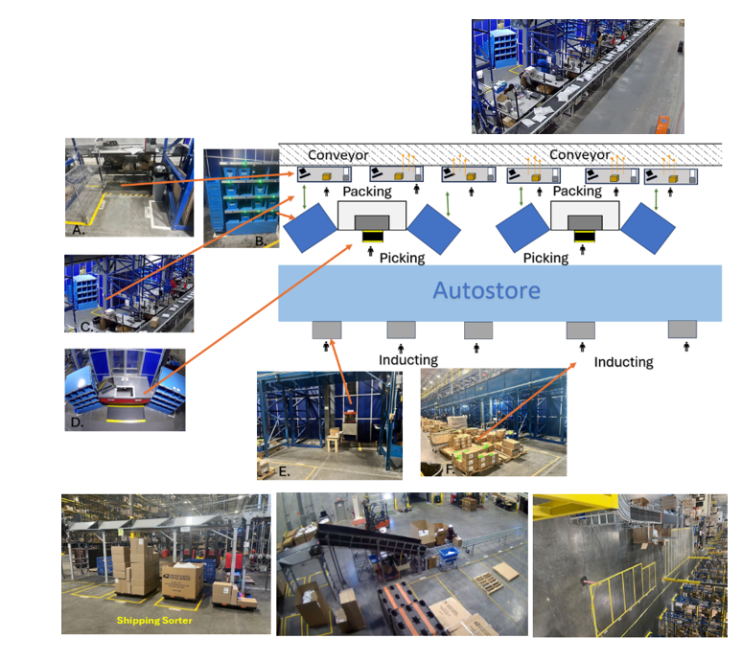

###### Business to Consumer

Business to Consumer (B2C) Orders are types of Sales Orders that will be shipped directly to a customer’s address either domestically or internationally using a Parcel Shipping Carrier such as UPS or FedEx. These orders will have an Order Type field (customAttribute2) set to ‘B2C’. All B2C orders will be allocated to the Autostore location. Any backorders will be replenished to Autostore and then picked out of Autostore. Under the B2C umbrella, there are multiple order classifications.

###### Single Unit Orders

Orders which are tagged as Order Type (customAttribute2) = ‘B2C’ and have a single line for a single unit of an item will be grouped together on Singles waves and sent to Autostore.

* When the wave releases and allocates pick tasks to the Autostore location, those pick tasks will be sent to the Swisslog API. The pick tasks will include the SKU, quantity to be picked, and pick task ID.
* A user will then perform picking directly in Autostore and will use a single large tote or gaylord for bulk picking single unit orders.
* Once a wave of single unit orders has been fully picked into a single large cart, the user will push the KBI light button and move the blue cart through to the opposite side of the putwall to the parcel shipping area adjacent to the Autostore grid.
* The order picked confirmation message will be sent from Swisslog to the Deposco REST API. This message will contain the container which has been picked into, the SKU, the picked quantity, and the pick task ID .
* Deposco will update pick tasks to complete based on those pick confirmation messages from Swisslog, decrement units from the Autostore storage location, and increment units in the cart container.
* A packing user will scan the cart in the Pack Order by Item process and then proceed to scan and pack one item/order at a time.
* For Gerber orders, rate shopping requests are sent out to parcel carriers, a service is automatically selected, and a shipping label automatically prints at the user’s pack station. For Intradeco orders, no rate shopping occurs and a parcel carrier request is sent for the shipping service which was set when the order first came into Deposco via API. The packing user labels the outside of the shipping container and places it on the conveyor belt. A shipment record is created with shipment lines and the Sales Order is updated.
* At the time of closing the shipment, a base orderShipped event will fire which will trigger Deposco to send the Envista conveyance system the tracking number and carrier information for the shipped container. Envista will scan the tracking number and divert the parcel to different gaylords where it either goes to a UPS, FedEx, USPS (Stamps), or pallet building area.

###### Multi Unit Orders

Orders which are tagged as Order Type (customAttribute2) = ‘B2C’ and are for 2 or more units will be grouped together on Multis waves and sent to Autostore.

* When the wave releases and allocates pick tasks to the Autostore location, those pick tasks will be sent to the Swisslog API. The pick tasks will include the SKU, quantity to be picked, and pick task ID
* A user will then perform picking directly in the Autostore and will use the large cart with individual picking bins. Each bin will correspond to a single order.
* As the picking user completes picking orders, they push the picking bin through and select the button on the blue KBI putwall to indicate to the packing user on the other side that a bin is ready for packing.
* A confirmation message will be sent from Swisslog to the Deposco REST API. This message will contain the container which has been picked into, the SKU, the picked quantity, and the pick task ID.
* Deposco will update pick tasks to complete based on those pick confirmation messages from Swisslog, decrement units from the Autostore storage location, and increment units in the picking container.
* A packer will then use the Cubed Packing process to pack and ship each bin. As the packing user scans the picking container, Deposco’s cartonization logic is executed to identify the optimal carton type. The packing user can select the suggested shipping container or override the selection. The items from the bin are then packed into the shipping container.
* Rate shopping requests are sent out to parcel carriers, a service is automatically selected, and a shipping label automatically prints at the user’s pack station. The packing user labels the outside of the shipping container and places it on the conveyor belt. A shipment record is created with shipment lines and the Sales Order is updated.
* At the time of closing the shipment, business rules in the Close Shipment step of the CubedPacking process will fire a custom orderShipped event which will trigger Deposco to send the Envista conveyance system the tracking number and carrier information for the shipped container. Envista will scan the tracking number and divert the parcel to different gaylords where it either goes to a UPS, FedEx, USPS (Stamps), or pallet building area.

###### Amazon.com Intradeco Orders

Orders which are Order Type (customAttribute2) = ‘B2C’ and have an Amazon trading partner and have the Fulfillment Type field set to Parcel will be grouped together and sent to Autostore. Unlike other B2C orders picked in Autostore, these orders will require retailer labels and will not be fully shipped in the parcel shipping area. These orders will be palletized.

* When the wave releases and allocates pick tasks to the Autostore location, those pick tasks will be sent to the Swisslog API. The pick tasks will include the SKU, quantity to be picked, and pick task ID
* A user will then perform picking directly in the Autostore and will use the large cart with individual picking bins. Each bin will correspond to a single order.
* As a user picks, confirmation messages will be sent from Swisslog to the Deposco REST API. These messages will contain the container which has been picked into, the SKU, the picked quantity, and the pick task ID.
* Deposco will update pick tasks to complete based on those pick confirmation messages from Swisslog, decrement units from the Autostore storage location, and increment units in the picking container.
* As the picking user completes picking orders, they push the picking bin through and select the button on the Autostore cart to indicate to the packing user on the other side that a bin is ready for packing.
* A packer will then use the Cubed Packing process to pack and ship each bin. As the packing user scans the picking container, Deposco’s cartonization logic is executed to identify the optimal carton type. The packing user can select the suggested shipping container or override the selection. The items from the bin are then packed into the shipping container. Deposco will not close the shipment at this stage.
* An SSCC retailer label will be generated and applied to the outside of each parcel as Cubed Packing is completed. A Contents label will also be printed at this step and placed inside the carton. The packed-but-not-shipped parcel will then be placed on the conveyor. Business rules in the Confirm Pack step of the Cubed Packing process will fire a custom orderPacked event which will trigger Deposco to send the Envista conveyance system the tracking number and carrier information for the packed-not-shipped container.
* The parcel will move down the conveyor and divert to the palletization area. There it will be palletized, added to a trip via Assign Trip to Container, and then closed. If routing is for parcel service, a parcel carrier request will be made and shipping labels returned for all parcels on the trip. If routing is for an LTL freight service, then no carrier request will be sent. This step will close the shipment and create shipment lines.
* Amazon will need an ASN once all cartons are fully shipped on the one shipment.

###### Special Embroidery Orders

Orders which are Order Type (customAttribute2) = ‘B2C’ and have a ‘Special Instructions’ note on the order header will be grouped together and sent to Autostore.

* When the wave releases and allocates pick tasks to the Autostore location, those pick tasks will be sent to the Swisslog API. The pick tasks will include the SKU, quantity to be picked, and pick task ID
* A user will then perform picking directly in the Autostore and will use the large cart with individual picking bins. Each bin will correspond to a single order.
* As a user picks, confirmation messages will be sent from Swisslog to the Deposco REST API. These messages will contain the container which has been picked into, the SKU, the picked quantity, and the pick task ID.
* Deposco will update pick tasks to complete based on those pick confirmation messages from Swisslog, decrement units from the Autostore storage location, and increment units in the picking container.
* As the picking user completes picking orders, they push the picking bin through and select the button on the Autostore cart to indicate to the packing user on the other side that a bin is ready for packing.
* A packer will then use the Cubed Packing process to pack (but not ship) each bin. As the packing user scans the picking container, Deposco’s cartonization logic is executed to identify the optimal carton type. The packing user can select the suggested shipping container or override the selection. The items from the bin are then packed into the shipping container. Deposco will not close the shipment at this stage.
* Deposco will generate and print a contents label which includes the special instructions stored on the order header note for the Embroidery as well as a barcode for the Pulse order number. The packing user will apply the label and manually carry the package to an embroidery staging rack.

A separate team responsible for embroidery then picks up the packages from the staging rack and takes them to the embroidery station. At this station, the custom embroidery is applied to the product. Once complete, the parcel is labeled and sealed and returned to the Exceptions Clerk. The Exceptions Clerk will then ship each parcel. The user will use the Single Container Packing process and scan the LPN barcode. This triggers the parcel carrier request. A shipping label is returned and automatically prints to the station of the user. The shipment is closed in Deposco and shipment lines are created and the user sets the parcel on the conveyor. A base orderShipped event will fire which will trigger a message from Deposco to Envista with the carrier and tracking information, and the parcel is diverted by Envista to the appropriate gaylord for pickup by the carrier.

###### Virtual Bundle Orders

Orders which contain a Virtual Bundle item will be tagged as Virtual Bundle orders and will be grouped together and sent to Autostore. These orders will be functionally similar to the Multi Unit Parcel flow. For these orders, the order line will be for the parent kit item. Master data will be stored in Deposco which maintains the list of component SKUs and quantities which make up the assembled item. These items will be flagged as Kit to Order.

* Deposco will allocate to the subcomponents and send pick tasks to Autostore for those subcomponents.
* A user will then perform picking directly in the Autostore and will use the large cart with individual picking bins. Each bin will correspond to a single order.
* As a user picks, confirmation messages will be sent from Swisslog to the Deposco REST API. These messages will contain the container which has been picked into, the SKU, the picked quantity, and the pick task ID.
* Deposco will update pick tasks to complete based on those pick confirmation messages from Swisslog, decrement units from the Autostore storage location, and increment units in the picking container.
* As the picking user completes picking orders, they push the picking bin through and select the button on the Autostore cart to indicate to the packing user on the other side that a bin is ready for packing.
* A packer will then use the Cubed Packing process to pack and ship each bin. As the packing user scans the picking container, Deposco’s cartonization logic is executed to identify the optimal carton type. The packing user can select the suggested shipping container or override the selection. The items from the bin are then packed into the shipping container.
* A rules based validation message will appear if the packer attempts to close a carton that does not contain all components of the kit.
* Rate shopping requests are sent out to parcel carriers, a service is automatically selected, and a shipping label automatically prints at the user’s pack station. The packing user labels the outside of the shipping container and places it on the conveyor belt. A shipment record is created with shipment lines and the Sales Order is updated.
* At the time of closing the shipment, business rules in the Close Shipment step of the Cubed Packing process will fire a custom orderShipped event which will trigger Deposco to send the Envista conveyance system the tracking number and carrier information for the shipped container.

### Allocation/Wave Release

Pick waves organize the daily flow of outbound order fulfillment work. Waving is an application of short-interval scheduling that selects a set of orders based on properties like planned release or ship time, then releases the work needed for those orders in an organized fashion, so that the work can be performed efficiently by a set of users within a work shift. Orders can be automatically be waved and released via scheduler at a regular frequency defined by the GERBER team. Currently, Gerber plans to manage the releasing of waves manually. Automated, scheduler-based waving will be phased in at a later date, but available to turn on by the Gerber team at any time.

**[GERBER will have the possibility to change the wave scheduler run times as needed within the scope of this project]**

This Main Wave Scheduler will include all wave classifications, discussed further below. GERBER can also manually release waves by manually running the scheduler or selecting orders and releasing them using the “Build and Release Wave” Process Action Link.

#### Order Release Profile Settings

An order release profile defines how orders are processed when a pick wave is released. This includes:

* How to allocate stock for order fulfillment.
* How to manage orders and order lines when there is an inventory shortage for an order (backorder policy).
* How to create pick tasks and their associated pick lines for allocated stock.
* How to group pick tasks into work groups.
* Which picking process to use for picking the orders on the pick wave.
* The default staging location that is assigned after the orders in the pick wave are picked.
* Multiple order release profiles can be created to accommodate different picking scenarios.

**Backorder Policy** – the following policies are available which determining how the system handles an inventory shortage for an order when the pick wave is released:

* All stock on every order of the pick wave to fulfill – Stock must be available to completely fulfill all order lines for every order on the pick wave. Otherwise, every order and order line on the pick wave is back-ordered.
* **All stock on order to fulfill** – Stock must be available to completely fulfill all order lines for an order. Otherwise, the order and its order lines are back-ordered. If stock is available to fulfill other orders on the pick wave, then those orders are released. Only orders that cannot be completely fulfilled are back-ordered.
* **All stock on order line to fulfill** – Stock must be available to completely fulfill an order line. Otherwise, the order line is back-ordered. If stock is available to fulfill other order lines on the order, then those order lines are released. Only order lines that cannot be completely fulfilled are back-ordered.
* **Some stock on order line to fulfill** – If at least some of the stock on the order line is available to fulfill the order line, then the order line is released. The Order Close Policy option for the order release profile then determines whether the rest of the order line is fulfilled.
* **Some stock on order line to fulfill (Do not break kits)** – For kit to order scenarios where stock is not available to completely fulfill an order line, then part of the order line is released as long as the available/allocated stock includes the components to build an entire kit. If an item for an order line does not include a kit assembly definition, then the order is released based on the same criteria as the Some stock on order line to fulfill option. For example, if an order is placed for a bicycle that is a kit item with two wheels and one frame, and only one wheel is available, then the order line for the bicycle moves to the Back Ordered status.

**Order Close Policy** – The following policies are available which determine whether an order is closed at the time of shipping if only part of the order ships because part of the order is backordered:

* **Don't close if backordered** – The shortage quantity is reflected in the Shortage Pack Quantity field for the order line, the status of the order line moves to Partial Released, and the status of the order header moves to Back Ordered. The order can then be included on a different pick wave and fulfilled.
* Close if backordered (Fill or Kill) – Shorted items are "killed" (canceled) from the order when the order ships, and the order is closed. A shipment line with a quantity of 0 (zero) is created for the killed line.
* Close if backordered (Fill or Kill No Zero SLs) but does not create 0 qty shipment lines – Shorted items are "killed" (canceled) from the order when the order ships, and the order is closed. No shipment line is created for the killed line. This setting is recommended for environments that integrate with e-commerce platforms such as Amazon Seller Central, Shopify, and WooCommerce.
* Close if backordered. Cancel single orders on Exception. (Fill or Cancel) – Shorted items are "killed" (canceled) from the order when the order ships, and the order is closed). A shipment line with a quantity of 0 (zero) is created for the killed line. If an exception is entered for a pick task that is associated with the order, then the order line is canceled. For singles orders or orders where exceptions are entered for all pick tasks for the order, both the order line(s) and the order header are canceled.

Below are the specific Order Release Profiles GERBER will be using. A full description of each setting option in the ORP can be found on the Deposco Help Site. The two primary ORPs used will be the Batch Picking ORP and the SingleScanPicking ORP. Both of these order release profiles will use a Backorder Policy known as **“some stock on orderline to fulfill”**. This means if any portion of any order is able to be allocated, Deposco will make the allocation even if it partially allocates a line or order. This will allow pickers to begin working on each order while a supervisor investigates the reason for the backordered portion. Deposco will use business rules in the shipping processes to prevent any order from shipping unless it has been either completely picked or if any backordered portion of the order has been canceled. If Gerber has a true shortage, they will cancel the backordered portion of the order and short ship. This will Back Order the order in SAP. Some customers do not allow backorders. If it back orders in SAP, the initial delivery will be marked as closed, the order itself will be Back Ordered. Customer service then manages whether the order is canceled or if a new delivery is made. If not canceled, then SAP will make a new 'delivery' for the remaining portion of the order. This will pull into Deposco and create a new fulfillment order to be waved, picked, packed, and shipped.

Another Back Ordered Policy which will be used in Autostore is “**all stock on order to fulfill”**. This means if any part of an order is not available in a picking location to hard allocate to then the entire order will backorder. This prevents partially shipping an order. In contrast, ORPs such as BatchPicking_PartialRelease or SingleScanPicking_PartialRelease use a Backorder Policy known as “some stock on orderline to fulfill”. This means the system will allocate any available stock it can find, even if that means partially fulfilling a line. Unfulfilled amounts will be left as backordered and will remain that way until the remaining line quantity is fulfilled or canceled. Cancellations at this stage will be made directly in Deposco.

Additional ORPs can be created as needed with settings configurable by the Gerber team and subject to change.

**BatchPicking ORP**

| **Setting** | **Configuration** |
| --- | --- |
| Backorder Policy | All stock on order to fulfill |
| Pick Option | No Zone |
| Order Close Policy | Don't close if backordered |
| Shipment Consolidation Option | Consolidate per Order Number |
| Pick Strategy | Location Pick Sequence |
| Pick Process to Use | Batch Picking |
| Eligible Pick Location Policy | All pickable and ready locations included |
| Pick Task Grouping Policy | Group by Order |

**SingleScanPicking ORP**

| **Setting** | **Configuration** |
| --- | --- |
| Backorder Policy | All stock on order to fulfill |
| Pick Option | No Zone |
| Order Close Policy | Don't close if backordered |
| Shipment Consolidation Option | Consolidate per Order Number |
| Pick Strategy | Location Pick Sequence |
| Pick Process to Use | Single Scan Picking |
| Eligible Pick Location Policy | All pickable and ready locations included |
| Pick Task Grouping Policy | Bulk Item Pick |

**BatchPicking_PartialRelease ORP**

| **Setting** | **Configuration** |
| --- | --- |
| Backorder Policy | Some stock on orderline to fulfill |
| Pick Option | No Zone |
| Order Close Policy | Don't close if backordered |
| Shipment Consolidation Option | Consolidate per Order Number |
| Pick Strategy | Biggest Pack First then Location Pick Sequence |
| Pick Process to Use | Batch Picking |
| Eligible Pick Location Policy | All pickable and ready locations included |
| Pick Task Grouping Policy | Group by Order |

**SingleScanPicking_PartialRelease ORP**

| **Setting** | **Configuration** |
| --- | --- |
| Backorder Policy | Some stock on orderline to fulfill |
| Pick Option | No Zone |
| Order Close Policy | Don't close if backordered |
| Shipment Consolidation Option | Consolidate per Order Number |
| Pick Strategy | Location Pick Sequence |
| Pick Process to Use | Single Scan Picking |
| Eligible Pick Location Policy | All pickable and ready locations included |
| Pick Task Grouping Policy | Bulk Item Pick |

#### Pick Wave Profiles

Pick Wave Profiles define the rules that are used to build a pick wave, including the naming convention for pick waves, the criteria for selecting orders, the maximum number of orders that are allowed in a wave, and the order release profile that defines how orders are processed when the pick wave is released.

Pick Wave Profiles are initially determined during POI, then executed upon by each pick wave profile. Orders are classified by distinct factors such as: order type, fulfillment type (i.e. freight or parcel), trading partners, total quantity, and special tags to help ensure picks are categorized into like groups. Pick Wave Profiles group orders to help increase the efficiency when orders are processed. Profiles should group orders in waves that meet their volume requirements.

GERBER will have the following wave rules:

1. B2B - Ready-to-Ship Full Case Picks Only - Parcel
2. B2B - Ready-to-Ship Full Case Picks Only - Freight
3. B2B - Eaches Order without trading partner-specific requirements (includes Fred Meyer, Meijer, etc) - Parcel
4. B2B - Eaches Order without trading partner-specific requirements (includes Fred Meyer, Meijer, etc) - Freight
5. B2B - Eaches Order with special carton requirements (includes Kohl’s Bulk and Amazon.com Intradeco.) - Parcel
6. B2B - Eaches Order with special carton requirements (includes Kohl’s Bulk and Amazon.com Intradeco.) - Freight
7. B2C - Single Unit Orders
8. B2C - Multi Unit Orders
9. B2C - Amazon Orders
10. B2C - Special Embroidery Orders
11. B2C - Virtual Bundle Orders

#### Cartonization at the Wave

With cartonization at the wave, the process of determining the optimal shipping containers for each order occurs when a pick wave is released.

Cartonization at wave release is used for the following wave types:

* B2B - Ready-to-Ship Full Case Picks Only - Parcel
* B2B - Ready-to-Ship Full Case Picks Only - Freight
* B2B - Eaches Order without trading partner-specific requirements (includes Fred Meyer, Meijer, etc) - Parcel
* B2B - Eaches Order without trading partner-specific requirements (includes Fred Meyer, Meijer, etc) - Freight

The following settings are enabled for this implementation:

* Cartonization Provider: Deposco
  + Deposco does support 3rd party cartonization providers such as OSCO, but Gerber will use Deposco’s native cartonization logic.
* Rate Shopping
  + This will only be used for parcel orders and include services from UPS, FedEx, and USPS (Stamps).
* Shipping Label Generation
  + Shipping Labels are generated, but not printed during wave release. They are stored in the database to be printed at the pack station.

The Single Container Packing process is used to print the shipping label and update the shipping status of the order. After the Single Container Packing process is complete, the shipping container can then be sealed and moved to the next step in the fulfillment process.

##### **Data Requirements**

* Pack Dimensions - all items must have valid pack dimensions (Length, Width, Height, Weight, WeightUom, DimensionUom) in order to be eligible for cartonization.
* Pack Additional Attributes - consider setting the Ready to Ship flag, Carton Group attributes. These attributes are considered when evaluating the optimal carton during cartonization.
* Units of Measure - all pack dimension UOMs must be in the same measurement system for a single pack.
* Carton Type Dimensions - all carton types must have valid dimensions (Length, Width, Height, Weight, WeightUom, DimensionUom) in order to be eligible for cartonization.
* Carton Type Additional Attributes - include a maximum weight limit. This attribute will be used when evaluating the optimal carton during cartonization.

## Picking Processes

Picking Processes are the first step towards fulfillment and are used to find and extract products from a warehouse to fulfill customer orders. GERBER will be using the Batch Picking and Bulk Picking(Single Scan Picking) processes in Deposco for this purpose.

#### Batch Picking

With Batch Picking, multiple orders are put on a wave and each order is picked into its own picking bin. Sortation of items into their respective orders happens at picking, avoiding this need at packing. The bins are then staged individually at packing stations for packing and shipping. This is used primarily for parcel orders.

**Handheld Process Configuration**

1. This process will only show waves that are to be fulfilled from the user’s facility.
2. Pickwaves will be sorted according to the wave number in descending order. (Wave number is based on date)
3. Only waves in “Released”, “Picking”, and “In Picking” status can be picked.
4. After batch picking, users will not be prompted to scan a staging location, the containers and stock will automatically be staged to the generic Shipping location.
5. There is no limit to the maximum quantity permitted for a single pick task.
6. A new pick task will be created when a user exceptions a pick task.
7. Stock Units at a location will NOT be set to ‘On Hold’ status if a user triggers a picking exception and a cycle count will be created for the location.
8. No items will require lot, expiration date, serial, or other forms of attribute tracking.

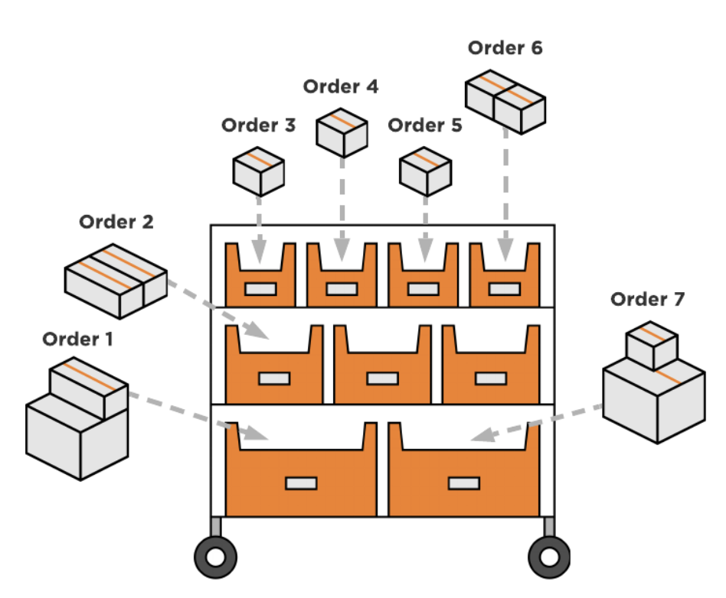

#### Single Scan Picking

Single scan picking (also known as bulk picking) is used to pick a group of orders into the same picking container. This is used primarily for large freight orders.

**Handheld Process Configuration**

1. This process will only show waves that are to be fulfilled from the user’s facility.
2. Pickwaves will be sorted according to the wave number in descending order. (Wave number is based on date)
3. Only waves in “Released”, “Picking”, and “In Picking” status can be picked.
4. After staging a picking container, users will be prompted to scan a new picking container and can continue picking the same wave/workgroup.
5. A new pick task will be created when a user exceptions a pick task.
6. Stock Units at a location will NOT be set to ‘On Hold’ status if a user triggers a picking exception and a cycle count will be created for the location.
7. After picking, users will be prompted to scan a staging location.
8. GERBER will pick into pallets created on the fly via pre-printed labels.
9. No items will require lot, expiration date, serial, or other forms of attribute tracking.

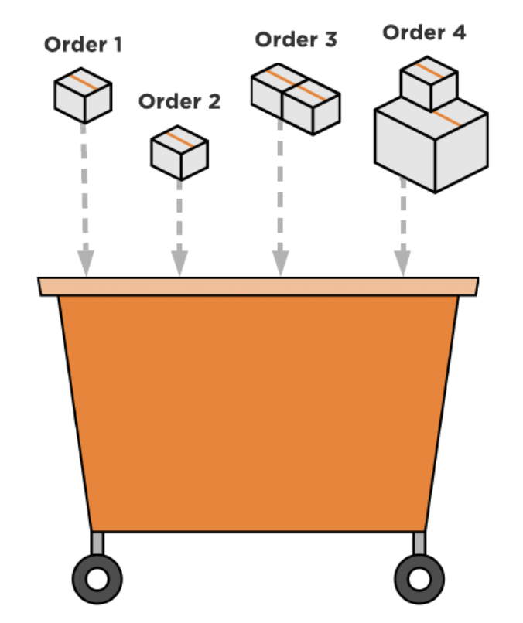

## Packing and Shipping Processes

The packing and shipping processes in Deposco are used to confirm exactly what is being shipped in specific bins/containers, confirm items and quantities, and print documentation such as packing slips, shipping labels, etc. The In Bins (API) field on the Order Header displays which container(s) an order is in.

The shipping method will be set upon order import and can be modified as needed prior to shipping.

#### Cubed Packing

The Cubed Packing process can be used to automate the shipping carton selection process as long as the picked items have valid dimensions (pack.length, pack.width, pack.height, pack.weight all in the same measurement system). As the user scans the picking container, Deposco’s cartonization logic is executed to identify the optimal carton type. The packing user can select the suggested shipping container or override the selection. The items from the bin are then packed into the shipping container. If the picked items do not have valid dimensions, or a different type of exception scenario occurs, an error message directs the user to the appropriate packing process. These exception-handling packing processes are detailed below. Example error message: “Container [SDAF1213] has invalid dimensions. Please update or use the [Batch Packing] process”. Order types which will use this process includes:

* Business to Consumer - Multi Unit Orders
* Business to Consumer - Retail including Amazon and Kohls (shipment closed in a later step)
* Special Embroidery Orders (shipment closed in a later step)
* Virtual Bundle Orders

**Cartonization in Cubed Packing**

Configure the following master data entities for cartonization: Ensure that the pack record for each item includes the dimensions (length, width, and height) and weight of the item/pack. A single item does not have dimensions and weight in more than one measurement system (imperial, metric). Configure a carton type of type Carton for each shipping box. The weight limit for parcel shipping is assumed to be 150 lbs (70kg). Therefore, the cartonization logic assumes that carton type records for shipping boxes are configured with a maximum weight capacity of less than 150 lbs. During cartonization, the smallest available shipping box (carton type) is selected. If the contents for an order do not meet the minimum fill percentage of the smallest box, then the carton type is still returned as the suggested box if the item/pack must be shipped in a box (in other words, as long as the item/pack is not a Ready to Ship, or RTS, item). The unit of measure (UOM) for each pack and carton type are stored in Deposco. The cartonization process supports UOM conversions so that items measured in both inches and centimeters can be packed together. All measurements for an item/pack or carton type record should use the same measurement system. In other words, if the dimensions are in inches, then the weight should be in ounces (oz) or pounds (lbs), not in kilograms.

**Rate Shopping in Cubed Packing**

Once the order has been cartonized and packed, the rate shop selection process is invoked, choosing the optimal shipping service for the order. Rate Shop Profiles are configured which maintain the list of carriers and services which Deposco should send rate requests for and consider in service selection. The optimal rate is selected and applied in the background. Users can validate the rate shop selection using the Ship Rate Quote related entity (tab) on the Sales Order. Rate shopping automation means from a user's perspective there is no need to select a shipping service, the rate shopping and service selection all occurs in the background in combination with the cartonization logic which determines the weight and optimal shipping container for each order.

#### Pack Order by Item

The Pack Order by Item process is used to pack and ship single unit orders that were picked via Single Scan Picking.

During Single Scan Picking, a group of orders is picked at the same time and placed into a single large cart or pallet. The items from the picking container are then packed into a shipping container during Pack Order by Item.

If applicable, shipping labels are printed (when the order’s ship via is not Ship Outside System) and the Shipping Status of each order moves to Shipped during the Pack Order by Item process.

**Handheld Process Configuration**

1. Weight will be automatically populated based on the pack weight and the quantity of the items in the container.
   1. If an item is marked as Ready To Ship (RTS) the dimensions and weight screen will be automatically calculated from the pack dimensions and weight and the Dims and Weight Screen will be skipped
2. Cartonization settings will be enabled to automate the carton selection process. A user will not have to select a carton.
3. Intangible items will be auto-packed for orders including items with the Intangible Item flag set to true.
4. A packing slip and shipping label will be printed for each item packed out.
5. Packing Slips and Shipping Labels will be printed to the printers with the same Active Resource as the user.
6. At completion of this process, the container will be packed and shipped, the customer order will be marked accordingly, and shipment records will be made accordingly.
   1. Users will need to ensure the package is physically sorted to the correct carrier and taken out of the building.
7. Order Header and Order Line notes can be displayed during this process.

#### Single Container Packing

The Single Container Packing process is used to ship parcels orders that were picked directly into a shipping container or in scenarios where packing occurs separately from shipping. For example, orders which were previously packed in a soft close process where dimensions were captured and labels were generated but a carton was not hard closed such as Special Embroidery Orders. Order types which will use this process includes:

* B2B National Retailers - Floor Only - Ready-to-Ship Case Picks - Parcel
* B2B National Retailers - Floor Only - Each Picks (includes Kohl’s, Frey Meyer, and Meijer) - Parcel
* B2B - Wholesale Independents - Floor Only - Ready-to-Ship Case Picks - Parcel
* Special Embroidery Orders

**Handheld Process Configuration**

1. Shipping labels are printed and the Shipping Status of each order moves to Shipped during the Single Container Packing process.
2. The container will become a ContainerHist record and stock will be fully decremented from the system.

#### Print2Panda

The Print2Panda process is used to print retailer-compliant carton labels. This process is only needed if the retailer for an order has specific carton labeling requirements, indicated by the tradingPartner.ssccNumbersRequiredForTrip field.

This process is initiated by the user scanning the pallet LPN. The contents of the pallet LPN is evaluated and then divided into inner containers based on the quantity of the case pack for each item. For example, if the case pack quantity for an item is 50, and 100 units exist on the pallet, the 100 units are split into two cartons (inner containers) of 50 units each. The inner container numbers are formatted based on SSCC requirements using the tradingPartner.ucceanCompanyNumber. Print2Panda supports generating SSCC labels for both ready-to-ship full cases and eaches which need to be packaged into cartons.

Example of Item Vendor records which are needed for the Print2Panda process:

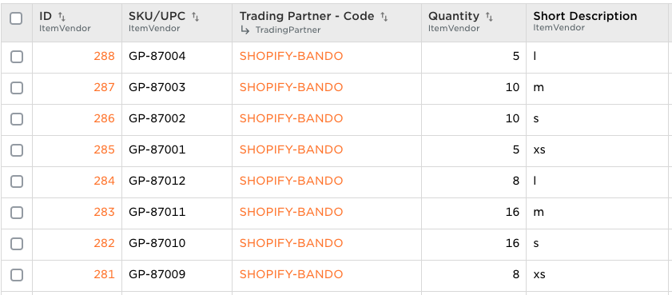

#### Trip Management and Assign Trip to Container (ATTC)

Freight and LTL order packing is performed using the Assign Trip to Container process. The user builds a Trip by first selecting a shipping door to initiate the process. Once a door is selected, the associated Trip number is assigned to the shipping door and the user begins adding shipping containers to the Trip by scanning each container/pallet. The user can scan a container/pallet again to remove it from the Trip.

**Handheld Process Configuration**

1. Orders shipped with ATTC will generate shipment records in Deposco
2. The ATTC process will allow containers of type ‘Pallet’ or ‘Case’ to be used.
3. Completion of the ATTC process will not close the trip. The Trip will remain in ‘Open’ status and the Shipment in ‘Shipping’ status.
4. Freight requests and routing will be performed outside of Deposco.

Freight orders have trips at the sales order level. A trip/load can consist of multiple orders and a sales order can have multiple trips/loads. This is the primary distinction between LTL/TL and Parcel workflows.

Calculated fields exist on the OrderHeader to estimate the number of cases, number of pallets, and total weight associated with the order. The following assumptions are included in these calculations:

* Pallet LxWxH: 40x48x60 in
* Pallet Weight: 20 lbs

Trips/Loads for freight orders are built sometimes multiple days in advance of routing.

A trip can be generated as shown below.

*Select Order(s) in the OrderHeader view > PAL: Create Add To Trip > Done*

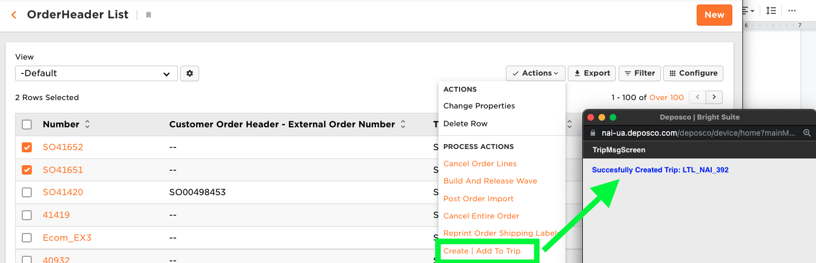

*The Trip is then displayed on the field named “Associated Trip (api)”*

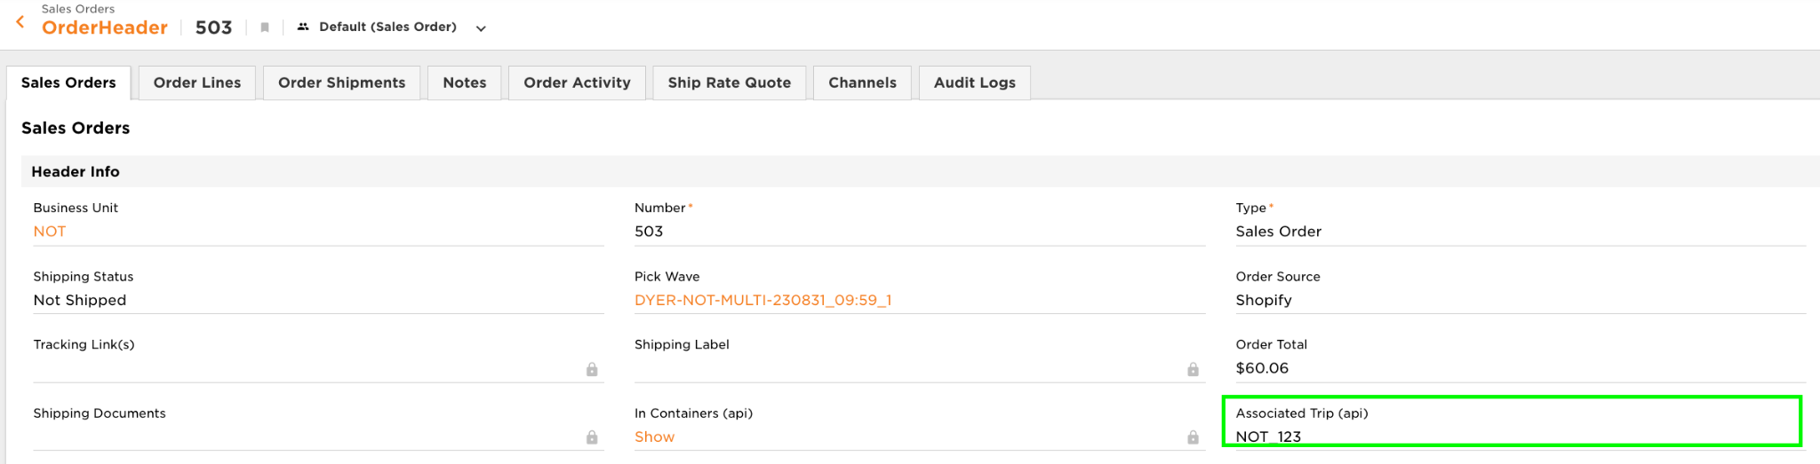

*In the Trip Management Application Menu > Trip.*

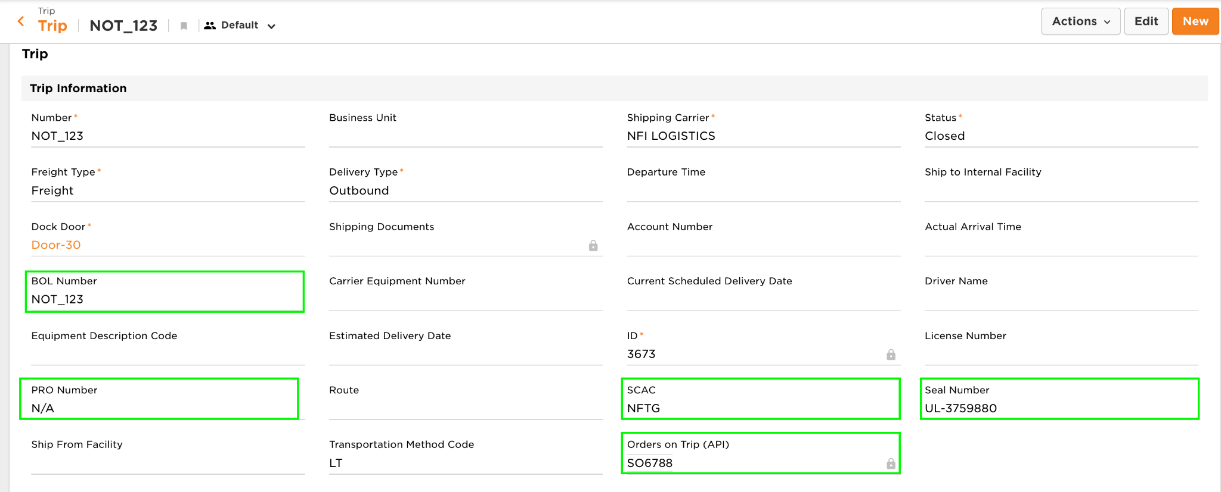

At this point the Trip management team can start entering Trip-specific information:

* PRO Number
* BOL Number
* SCAC Code
* Estimated Pick Up Date

The Trip created via the PAL is in a status of Planned with no specific dock door yet assigned. Before the floor users begin loading the pallets onto the trip, the trip management team must update the trip status from ‘Planned’ to ‘Open’ and assign the trip to a shipping door. To note, only one open trip can be assigned to a dock door at a time.

The floor user is prompted to first scan the staging location where their pallets reside. If a trip has pallets in multiple locations, the operations team needs to consolidate the pallets to a single location prior to beginning the AssignTripToContainer process. There is a validation to force the user to scan pallets assigned to the order to the trip. If a user attempts to scan a pallet that is not associated with one of the orders on the trip, an error message is displayed.

The user selects the shipping door to be used for the trip and begins scanning outbound pallets to assign each of them to the trip. After all pallets have been scanned onto the trip, the user is not taken to the Custom Details Input Screen to enter routing information such as the SCAC code and PRO number. This is done by the back office team.

A trip may be ‘soft closed’ within the handheld. A soft close can trigger printing documents such as a BOL and leaves the trip open and the shipment is not marked as shipped. If the BOL requires updated information, the respective fields can be updated on the trip or shipment entity within the UI. At this point, a packing slip can be generated by the floor team based on the pallets assigned to the trip. This packing slip is available via a Trip-level PAL as well as the Print Entity process on the handheld device.

Once all outbound pallets have been physically loaded onto the truck, a PAL on the Trip is used to hard close the trip. At this point, the trip is marked as closed and the shipment is marked as shipped. When the trip is hard closed, the finalized BOL is printed.

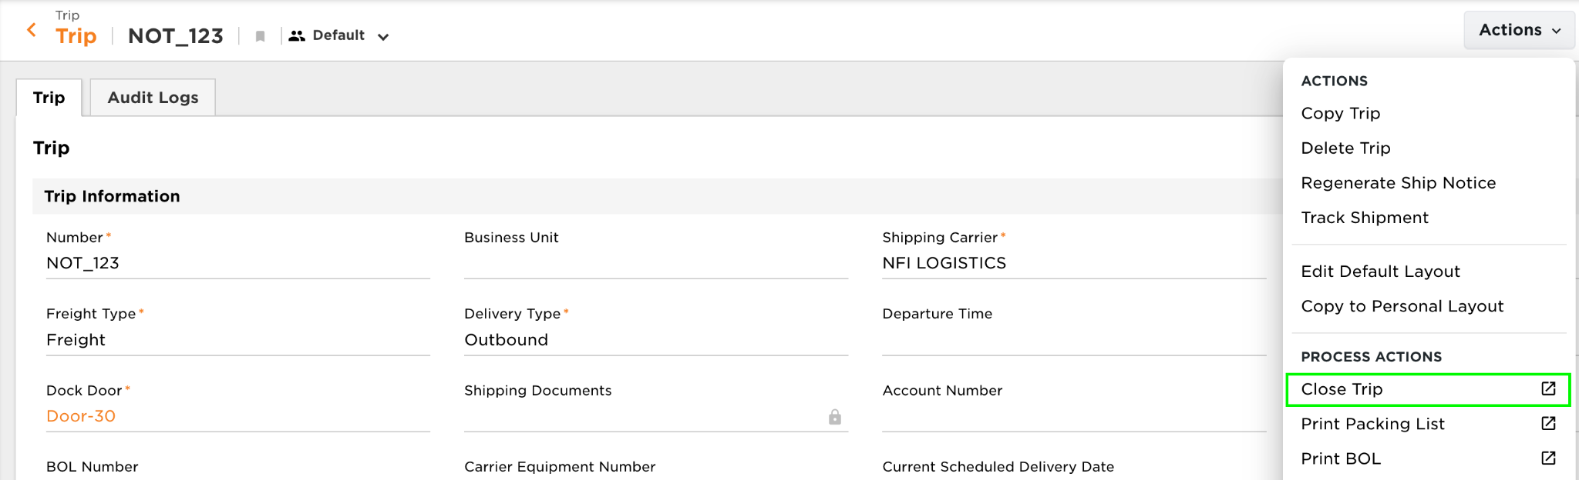

#### GERBER Non-Integrated Ship Vias

In addition to the Ship Via’s used by the respective shipping carriers, GERBER will also have distinct Ship Via’s listed in Deposco that do not call any shipping carrier, but make all the proper shipping updates for orders in Deposco. Gerber maintains a master list of freight shipping services which will be uploaded into Deposco using ‘Ship Outside System’ as the Method Code and Vendor Code. These services can be named Below are the Deposco names of these Ship Vias:

| **Ship Via** | **Description** |
| --- | --- |
| Ship Outside System | Used for Freight Shipments to be shipped using Assign Trip to Container and Manual Close Trip. Shipping Requests and Routing will be done outside of Deposco. |

[GERBER will have the possibility to add additional ShipVia’s as needed within scope]

#### 

#### Retailer Requirements

Retail requirements are based on the trading partner assigned to the sales order. Specific fields on the trading partner control the printing of carton labels and packing slips.

| **Attribute** | **Values** | **Description** |
| --- | --- | --- |
| Packing Slip Report | String | Evaluated during packing. Determines the packing slip report used. |
| ZPL Label Report | String | Evaluated during packing. Determines the carton label report used. |
| SSCC Numbers Required for Trip | TRUE/FALSE | Evaluated during packing. Determines if an order requires SSCC label generation. |
| UCCEAN Company # | Integer | Evaluated during SSCC label generation. |

**Carton Labels**

A generic carton label is configured by default. The following trading partner carton labels are in scope for the initial implementation:

1. Walmart
2. Target
3. Kohl’s
4. Amazon
5. Catco Siman
6. Intradeco - BiMart
7. JCPenny
8. Burlington
9. Costco
10. [Gerber team has provided a full list of ~34 unique carton labels used by a variety of trading partners: [Shipping Folder](https://drive.google.com/drive/folders/1I7dwFR5fXXGsNO49sETez1kshy3YY0ZO?usp=drive_link)]

The operations team is responsible for providing accurate sample carton labels for each retailer and verifying the correct printing and formatting of each label during the testing phase of the implementation.

#### Reset Sales Order

The Reset Sales Order workflow process enables you to reset the status of an order and its order lines to a status of New. The reset process also:

* Removes any pick waves that are assigned to the order.
* Deletes any associated pick tasks, pick lines, and pick detail records for the order.
* Deallocates any stock that has been allocated for the order.

As an example, this process can be used to remove an order from a pick wave without undoing the entire pick wave, or to reset the order to a status of New after the order has been picked but before the order has been packed.

Note 1: Picked Stock Units, on a Sales Order that is reset though the Reset Sales Order process, will remain in the Picking Container used in the Picking process. The Picking Container will be located in the default Staging Location.

**Handheld Process Configuration**

1. The following order statuses are eligible for a reset: New,Complete,Back Ordered,Released,Picking
2. The following pick task statuses are eligible for a rest: Complete,Inactive,Exception,Picking,Staging,Suspend,Released

# Other handheld Processes

## Warehouse Lookup

The Warehouse Lookup process allows users to enter warehouse identifiers, such as item barcodes or location barcodes, to display more detailed information about the selected entity. Scan or enter an identifier for the entity, and then key information for the entity appears on the lookup screen, such as the locations, packs, and quantities for an item or the order status, shipping status, and shipping method for a sales order. The summary of cycle counts at a facility can also be viewed.

## Change Resource

A resource connects a user to a printer assignment, and enables the Deposco system to direct print jobs to specific printers for processes that the user performs. The Change Resource process allows users to verify their active Resource assignment and change their Resource to Resources within their current facility assignment.

## Change Zone

The active zone for your user account determines the warehouse tasks that you can perform for workflow processes such as batch picking and single scan picking. Each user account can be assigned to multiple zones based on the zone assignment settings for the account, but can only be active in a single zone at a time. The Change Resource process allows users to verify their active Zone assignment and change their Zone to Zones within their current facility assignment.

## LPN Printing

Gerber Childrenswear will have a process to print randomly generated LPN Labels.

# Import/Export Data Files

Data files can be Import/Exported multiple ways from Deposco. The tools such as, Message Center, Data Exchange, and UI Exports are used for this purpose.

## Data Exchange

Data Exchange is a method of importing data into Deposco via CSV upload. It can be used for basic templates, such as Locations and Zones, as well as multi-entity templates, such as the combination of OrderHeader and OrderLine or Item and Packs.

Import:

Gerber Childrenswear will use Data Exchange imports for Locations, Zones, CartonTypes, Containers, Packs, SOs, POs, and optionally other entities.

Exports:

Gerber Childrenswear will need Data Exchange exports to SAP including Purchase Order Receipts, Customer Return Receipts, Customer Orders, Ship Notifications, Inventory Adjustments, and Work Order Build Results. Other data types and reports may be configured for export as well.

## UI Exports

Exporting data files from the Deposco UI can be useful when sending data files to non-Deposco users about any transactional data needed. The ‘Export’ option for data view is listed where allowed.

# Reporting

## Process Reports

Process Reports are reports that will be printed within the transactions of the WMS processes.

* Parcel Shipping Label
* Gerber Packing Slip
* Commercial Invoice
* Special Instructions Label for Embroidery Orders
* Item Label
* 4x4 LPN Contents Label
* SSCC Labels
* Retailer Compliant Packing Slips
* 8.5x11 Pallet Placards
* Bill of Lading

## Operational Reports

Gerber Childrenswear will use base Deposco reports found in the Reports and Metrics section of the UI or create reports from the Report Builder Entity. Additionally, custom reports can be generated using pre-built templates as well as the self-service Report Builder application. The Deposco team will provide training and support on how to use Report Builder for generating various reports. Any custom changes to base reports requiring the Deposco team will be scoped and executed against the estimated reporting hours allocation. Below are example reports which will be created.

| Deposco Report | Description |
| --- | --- |
| Order Summary Dashboard | This dashboard shows the breakdown of Sales Orders by status for the selected time frame |
| Pick Tasks Completed by User | This dashboard shows the number of completed pick tasks by user for the selected time frame |
| Orders Packed by User | This dashboard shows the number of packed orders by user for the selected time frame |
| Daily, Monthly, and Quarterly Fulfillment Reports | These reports show the number of orders Picked/Packed/Shipped broken out by day, month, and quarter.. |

# 

## Gap Analysis

## Open Topics / Gap Matrix

| Unresolved Topic / Gap | Description | Comments |
| --- | --- | --- |
| Topic #1 | E-commerce / marketplace integrations  **Decision**: Ecommerce data to flow through SAP. | * Gerber would like to replace current middleware between ecomm platforms and SAP with Deposco * Deposco must align with SAP allocation so orders should come from SAP, Deposco’s suggested approach is orders all come through SAP and ship notices are sent back to SAP which relays to the ecomm platforms * Another possible approach is orders come through SAP, but items are pulled from e-comm platforms and linked via Channel Listings and ship notices are sent from Deposco to ecomm platforms directly. * An unresolved question with this approach is how would Deposco get Channel Xrefs for Orders & Order Lines (which would be needed to link the Shopify Ref1/Ref2 IDs and Deposco internal IDs)? These channel xrefs are a prerequisite to sending successful ship notices. * Deposco recommends having ecomm data flow through SAP. |
| Topic #2 | B2B Cartonization Scenarios  **Status**: Deposco recommending use of the Print2Panda process (i.e. post-picking pallet scan for generating carton labels) for handling ‘single SKU carton’ and ‘specific unit per carton’ requirements  **Decision**:  For Full Cases Zones, Deposco uses cartonized waving to generate 1 SSCC carton label per ready-to-ship case.  For certain order types which go to Floor Eaches/PickPack, Deposco will also use cartonized waving.  For special orders (e.g. Kohl’s Bulk orders or Amazon.com Intradeco), Deposco will NOT cartonize at waving. Instead, Gerber will maintain ItemVendor data which stores the units per carton requirements per SKU per trading partner. Gerber will pick to pallet, stage the pallet, and then after that picking/staging occurs a user will use the Deposco “Print2Panda” process (unrelated to Envista, we will refer to this process as Print SSCC Retailer Labels at Packing) and use ItemVendor records. | * Ongoing discussion with Gerber team on identifying cartonization requirements for different B2B order types. * In cartonized waving, Deposco only supports volumetric calculation and cannot force single SKU cartons. However, Deposco does have a post-pick process called Print2Panda (NOT related to Envista Print and Apply machine) which does support limiting cartons to a single SKU and specifying specific units per carton based on trading partner requirements. * A Deposco partner, OSCO, may be able to handle advanced cartonization conditions. Deposco is actively working through discovery on these requirements with the Gerber team |
| Topic #3 | SAP Inventory Messages  **Status**: Deposco recommending use of moves to non-available zones/locations. Gerber team asking for a method of communicating pallets which are frozen in their existing location and not moved.  Update 2/13 - Deposco exploring internally with our product team possible methods of communicating inventory which is made unavailable without an adjustment (e.g. if a Location’s status is updated to ‘On Hold’).  **Decision**: Deposco has an upcoming product enhancement called Inv Ledger which will replace the existing inventory general ledger. This new Inv Ledger will track “*goods movement records that can move inventory between an Unavailable bucket and an Available bucket, and track these from and to movements - Deposco will record a move when the status of stock changes between available and unavailable, such as moving a case to an On Hold location or flagging a stock unit as Damaged.*” This can be used to capture adjustment records which can be pushed to SAP in the scenarios discussed where Locations need to be put in an On Hold status without moving inventory. This product should be available in April 2025. | * Gerber currently sends inventory adjustments messages to SAP with hundreds of unique possible code combinations. * Deposco team is working on identifying the 5-6 codes which are important to SAP and identifying scenarios when each of those codes should be communicated based on activity in the WMS. * One unresolved question is how Gerber’s current method of using ‘lock codes’ will be implemented within Deposco. Current system allows users to capture an attribute on stock which triggers a message to SAP. This does not adjust on hand inventory in the WMS or in SAP, but does affect SAP’s available to promise inventory calculation. At the moment, Deposco does not have an automated method of capturing a ‘lock code’ type attribute. Deposco could have a flag on stock unit, but the existing inventory general ledger does not store transactions for manually flagging stock unit attributes. * Deposco recommends using inventory adjustments and cycle counts which can be communicated to SAP. |
| Topic #4 | Trading Partner SKU Conversion  **Decision**: Gerber will not use Work Orders. Instead, Deposco will implement the Re-Work process for trading partner SKU conversion. Example flow - SAP Sales Order pulls into Deposco, Gerber 'ships' the Walmart Case, Deposco Notifies SAP, SAP creates an Inbound ASN that imports into Deposco, Gerber 'receives' as Generic Case (if more inventory needed for mom-and-pop customers) or as Generic Eaches (if more inventory is needed for B2C Autostore orders) | * Gerber maintains separate SKUs and inventory for the same physical item sold to different trading partners. Depending on demand, Gerber will at times decrement a SKU for one trading partner (e.g. Walmart), remove the original tags, re-tag it for the new trading partner, and increment inventory for another trading partner’s SKU (e.g. Target). * Initial scope for this was to import work orders from SAP/Intradeco, execute the SKU conversion against a work order, and then communicate the resulting work order build details and inventory changes back to SAP/Intradeco. * The downside of the work order approach is that master data must be set up and maintained; there must be many-to-many KitHeader relationships detailing all input and output conversion combinations and the imported work orders must specify the specific KitHeader. For example, Walmart to Target, Walmart to Kohl’s, Target to Walmart, Target to Kohl’s and so forth * Deposco and Gerber team to discuss further the requirements needed from an ERP perspective and whether alternate approaches such as inventory adjustments or Kit to Stock may be used instead. |
| Topic #5 | Freight Routing ([Gerber Routing Table Link](https://docs.google.com/spreadsheets/d/1WWmy8PTOLOVSFyf457vVYFtIZ8_fQFRN/edit?usp=sharing&ouid=110466678892340239679&rtpof=true&sd=true))  **Status**: Deposco scoping expected all freight routing to be handled outside of Deposco. The Gerber team has requested that freight routing be handled within Deposco including use of routing tables and dynamic routing. Deposco reviewing if Decision Service and post order import automations/rules could be used and also discussing with WMS and OMS product owners.  **Decision**: Pending. Gerber team has agreed that the Routing topic will need further time to design a solution for. This will be scoped in an addendum document follow up to this master design document. | * From the Design Document, “*Gerber manages freight routing for Retail B2B customers outside of Deposco*.” An upload or manual entry would set the SCAC, PRO number, and Load ID values on a Trip record. * Deposco does not typically manage routing tables. Existing customers use an external TMS or other method of managing. Deposco has some integrations with freight carriers or freight middlewares which are not a part of the Gerber project scope. * The existing Deposco ‘Routing Response API’ is not applicable here as that is only used for scenarios where Deposco sends routing requests and stores routing responses. The Gerber team will handle routing requests and responses outside of Deposco. |
| Topic #6 | Different SKUs (B2B Each and B2C Each) have the same UPC  **Status**: Deposco team internally exploring possible options of handling to present to Gerber for review.  **Decision**: All trading partner specific B2B items (Walmart, Target, etc) will have a single unique GTIN stored in our Item UPC table and need to have the true UPC for those items specifically stored on an attribute on Item. That value will never be scanned for those SKUs but it will be printed on item labels when needed.  A Generic SKU will exist with Eaches stored in Autostore for B2C customers and Cases will be stored in B2B zones for mom-and-pop customers. These are not branded. This SKU will have 2 Item UPC records: both the true UPC (which the Eaches will use) and the generic GTIN stored on the cases.  Example here: [Gerber B2B vs B2C SKU Master Data](https://docs.google.com/spreadsheets/d/1DuWfm54rB5Xy8h89jdmmV-sH0_WCWnXBbGAZmykNDTw/edit?usp=sharing) | * Gerber uses Trading Partner-specific SKUs which are received, stored, and shipped as ready-to-ship cases each with their own unique GTIN barcode on the outside of the case (Walmart case, Target case, Kohl's case, etc). Inside of those cases are eaches with their own separate barcode - the UPC - and the eaches inside a Walmart case have the same UPC as the eaches inside a Target case which have the same UPC as the eaches inside a Kohl's case and so on. * There are 4 scenarios where Gerber would break open a case. * Scenario #1 - when Gerber needs to convert to a Generic Case so that the case may be sellable to Trading Partners which do not have specific labeling requirements (including Amazon.com Intradeco and mom-and-pop wholesale) * Scenario #2 - when Gerber needs to convert from one trading partner case to another (e.g. Walmart to Target) * Scenario #3 - when Gerber needs to convert from a trading partner case to a Generic Each in order to replenish Autostore and fulfill B2C orders. * Scenario #4 - when Gerber replenishes the B2B Eaches zone where a subset of trading partners allows ordering/picking Eaches (including Kohl’s, Fred Meyer, Meijer, Ross, Macy’s, and others) * For Scenario #4, the Eaches stored in the B2B Eaches zone are different SKUs than the Generic Eaches stored in Autostore but have the same UPC barcode. Deposco does not allow multiple SKUs to have the same UPC. * Gerber team has requested that Deposco design a solution for allowing a barcode scan of both the B2B Each SKUs and the B2C Each SKUs even though systemically they can not both have the same UPC stored in Deposco. |

# 

# 

# 

# 

# 

# 

# 

# 

# 

# 

# Customer Agreement

Your signature is required as proof of understanding and acceptance of the design document as described above. Upon acknowledgement of your approval, Deposco will engage in development of the work stated in this document and the design specification. Please review this document in its entirety. Upon approval, please sign, date and return.

**Deposco, Inc.**

**A Delaware Corporation**

| By: |  |
| --- | --- |
| Name: |  |
| Title: |  |
| Date: |  |

**Gerber Childrenswear**

**A DELAWARE LIMITED LIABILITY COMPANY**

| By: |  |
| --- | --- |
| Name: |  |
| Title: |  |
| Date: |  |